بسم الله الرحمن الرحيم



**The National ICT Up Skilling Program – Capstone Project**

**Al-Hussein Technical University**

Prepared by:

**Bassil Alqadi**

Supervisor(s):

**Dr. Jalal Kiswani**

**Dr. William Smairat**

**Dr. Jacquelyn Brown**

20 / 10 /2020

Table of Contents

1. Introduction: 4

2. Project Details: 4

1. Technology: 4

2. Requirements: 8

3. Design: 9

4. Development: 44

5. Testing: 45

6. Deployment: 47

3. Screenshots: 48

4. Source code Excerpts: 55

5. Conclusion: 64

Figure 1: Digital around the world 6

Figure 2: Book national stage table 7

Figure 3: Book training room table 8

Figure 4: Buy book table 8

Figure 5: Publish Manuscript table 9

Figure 6: Version Control Example 9

Figure 7: Wireframe - Home page 12

Figure 8: Wireframe - Minister of Culture 13

Figure 9: Wireframe - Culture Care Law 14

Figure 10: Wireframe - Prev ministers 15

Figure 11: Wireframe - Cultural agreements 16

Figure 12: Wireframe - organizational chart 17

Figure 13: Wireframe - Strategic plan 18

Figure 14: Wireframe - Directors 19

Figure 15: Wireframe - Cultural centers 20

Figure 16: Wireframe - Systems 21

Figure 17: Wireframe - Arab ammo project 22

Figure 18: Wireframe - Festivals 23

Figure 19: Wireframe - Jordan family library 24

Figure 20: Wireframe - Ministry prizes 25

Figure 21: Wireframe - The Jordanian National Thesaurus for Folklore Project 26

Figure 22: Wireframe - The Mobile Theater Laboratory Project 27

Figure 23: Wireframe - Cultural-Committees 28

Figure 24: Wireframe - Drama 29

Figure 25: Wireframe - Fine art 30

Figure 26: Wireframe - Folk art 31

Figure 27: Wireframe - Music 32

Figure 28: Wireframe - Singing 33

Figure 29: Wireframe - The Theater 34

Figure 30: Wireframe - Jordanian writers 35

Figure 31: Wireframe - Directories 36

Figure 32: Wireframe - Services 37

Figure 33: Wireframe VS Mockup 38

Figure 34: Mockup - Home page 39

Figure 35: Mockup - About ministry 40

Figure 36: Mockup - Minister of Culture: 41

Figure 37: Mockup - Perv. Ministers 42

Figure 38: Mockup - Directors 43

Figure 39: ERD - Service1 44

Figure 40: ERD - Service2 44

Figure 41: ERD - Service3 45

Figure 42: ERD - Service4 45

Figure 43: Hosting website files and assets 49

Figure 44: Website domain name 50

Figure 45: Home Page 50

Figure 46: Minister Word 51

Figure 47: About the ministry - 1 51

Figure 48: About the ministry - 2 51

Figure 49: Cultural event calendar 52

Figure 50: Footer 52

Figure 51: Ministry location 52

Figure 52: Services Page 53

Figure 53: Service 1 - Book National stage 53

Figure 54: Service 2 - Book national stage training room 54

Figure 55: Service 3 - Publish Book 54

Figure 56: Service 4 - Buy book from Jordanian writers 55

Figure 57: Cultural Agreements 55

Figure 58: Prev. Ministers 56

Figure 59: Contact us - 1 56

Figure 60: Contact us - 2 57

Figure 61: Home Page - News Section 58

Figure 62: Service one - PHP Code 59

Figure 63: Service 2 - PHP Code 60

Figure 64: Service 3 - PHP Code 61

Figure 65: Service 4 - PHP Code 62

Figure 66: Contact Us - PHP Code 63

Figure 67: Admin Login - HTML Code 64

Figure 68: Admin Login - PHP Code 64

Figure 69: Add News - HTML Code 65

Figure 70: Add News - PHP Code 65

# Introduction:

In these days, web development technologies are increasing rapidly. Every few days a new framework or library is been developed. Although we see a lot of websites that have an old design or “bad looking” structure. For that, web developers should have much information about technology trends to be able to develop best websites or application in the most efficient way.

Also, as we all know, most people in these days access the internet using their mobile phone, so the importance of developing a cross-platform websites become a necessary.

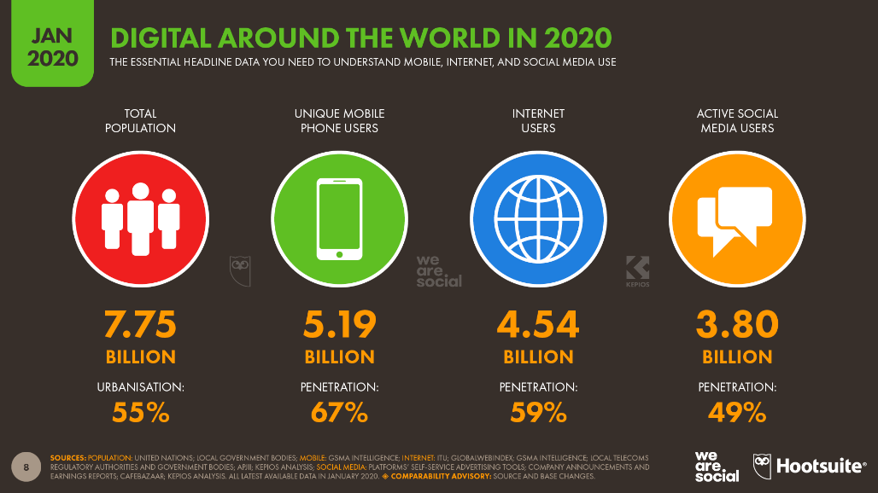

Figure : Digital around the world

# Project Details:

In this section, the project details in general will be shown such as: Technology used, user requirements, design, development, testing and deployment.

## Technology:

For building the ministry of culture website and the services within it, some web technologies were used to make it easy to develop the website using less time and effort. The technologies that were used are as follow:

* **Front-End**: For the frontend part of the website I used Bootstarp4.5 to build and control the layout of each page on the website. Also, I used bootstrap components such as: Navbar, Cards, Alert boxes, and Forms. However, HTML5, CSS3, JavaScript were used also in this part to display the web elements in the browser using html5 tags, and to give each element a style using css3, and to give the functionality to the website using JavaScript.
* **Backend:** In the backend part, PHP where used in the e-services on the website. It handles the data which the users enter in the form for each service. After that, the data is been validate and stored into the database for each user.
* **Modeling:** Each system should have a place where data is been stored in. This data usually is stored into table which have relationships between them. However, to display these tables and their properties and the relationships between these tables we used a model or diagram called ERD (Entity relationship diagram. In this project I used an online tool called draw.io to build the ERD, and it is as follow:

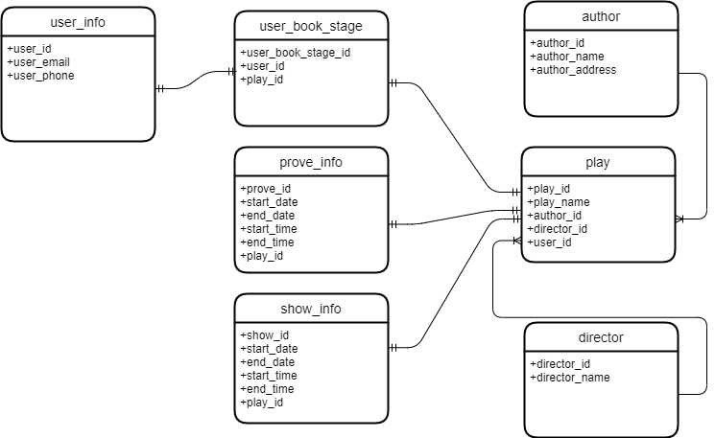

Figure : Book national stage table

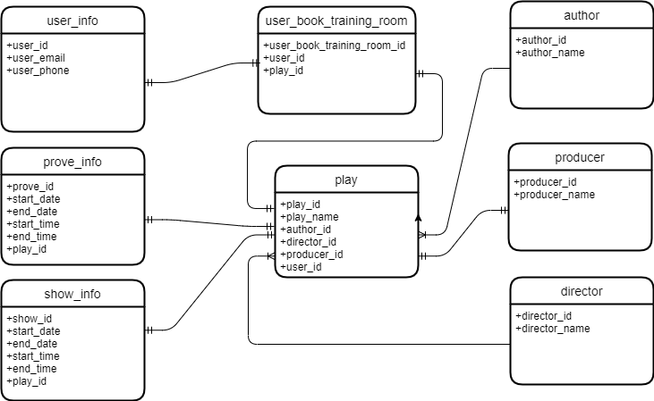

Figure : Book training room table

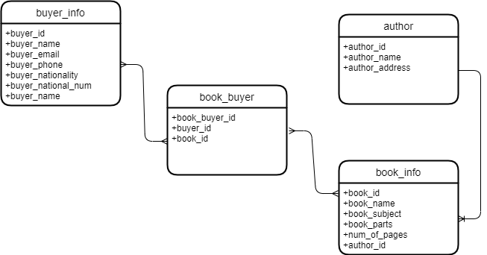

Figure : Buy book table

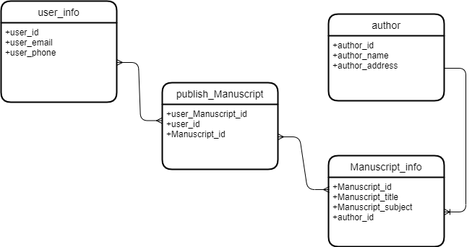

Figure : Publish Manuscript table

* **Version Control:** is a system that records changes to a file or set of files over time so that you can recall specific versions later. In this project I used Git system. And Git is a [distributed version-control](https://en.wikipedia.org/wiki/Distributed_version_control) system for tracking changes in [source code](https://en.wikipedia.org/wiki/Source_code) during [software development](https://en.wikipedia.org/wiki/Software_development). It is designed for coordinating work among [programmers](https://en.wikipedia.org/wiki/Programmer), but it can be used to track changes in any set of [files](https://en.wikipedia.org/wiki/Computer_file). Its goals include speed, [data integrity](https://en.wikipedia.org/wiki/Data_integrity), and support for distributed, non-linear workflows.

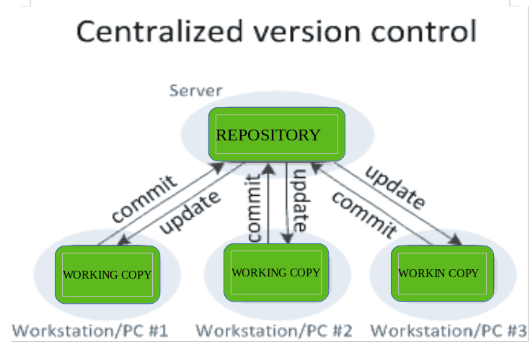

Figure : Version Control Example

## Requirements:

* User Requirements:

|  |  |
| --- | --- |
| # | Requirement Description |
| 1 | The admin shall be able to login to the CMS. |
| 2 | The admin shall be able to add news to the website. |
| 3 | The admin shall be able to view all stored new. |
| 4 | The admin shall be able to delete news. |
| 5 | The user shall be able to book the national Jordanian stage. |
| 6 | The user shall be able to book the national stage training room. |
| 7 | The user shall be able to buy book from the website. |
| 8 | The user shall be able to publish manuscript from the website. |

* System Requirements:

|  |  |
| --- | --- |
| # | Requirement Description |
| 1 | The system shall be able to validate admin’s credentials. |
| 2 | The system shall be able to send and receive data from the server (DB). |
| 3 | The system shall be able to work on all devices (Responsive). |
| 4 | The system shall be able to validate data that was entered by user in each e-service before storing it in the database. |
| 5 | The system shall be portable, so moving from OS to another will not cause any problem. |

* Page Description:
  + **Home Page**: This page called index page, and it is the most important page in the whole website. Many sections can be displayed in the home page, such as: Minister word, News section, Cultural events, Ministry magazines, etc.
  + **Minister word page**: In this page I select a speech for the minister of culture and display it.
  + **Cultural agreements page**: All cultural agreements between Jordan and other countries are shown in this page.
  + **Previous ministers page**: In this page I select 6 previous ministers and displayed general information about them.
  + **Jordanian writers page**: In this page Some of Jordanians writers are selected, and general information about them are displayed.
  + **Services page**: This page has a huge importance, because it allows the users to use 4 services on the website. The first service is to book the national Jordanian stage. Second service is to book a training room in the national stage. Third service is to buy a book online from any Jordanian writer. Fourth service is to publish a manuscript or support a Jordanian writer.
  + **Contact us page**: In this page the user can send his feedback about the overall experience using the website.

There are many pages on the website, but these are the most important pages.

## Design:

In this section I will descript the steps of how I design the website from scratch.

* **Wireframe:** Wireframes are used early in the development process to establish the basic structure of a page before visual design and content is added. It makes it easier to the developer to make a wireframe before start building any website.

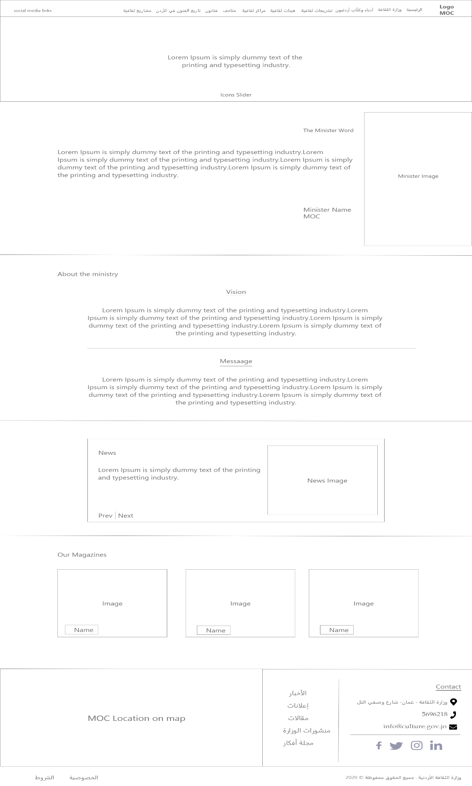

Figure : Wireframe - Home page

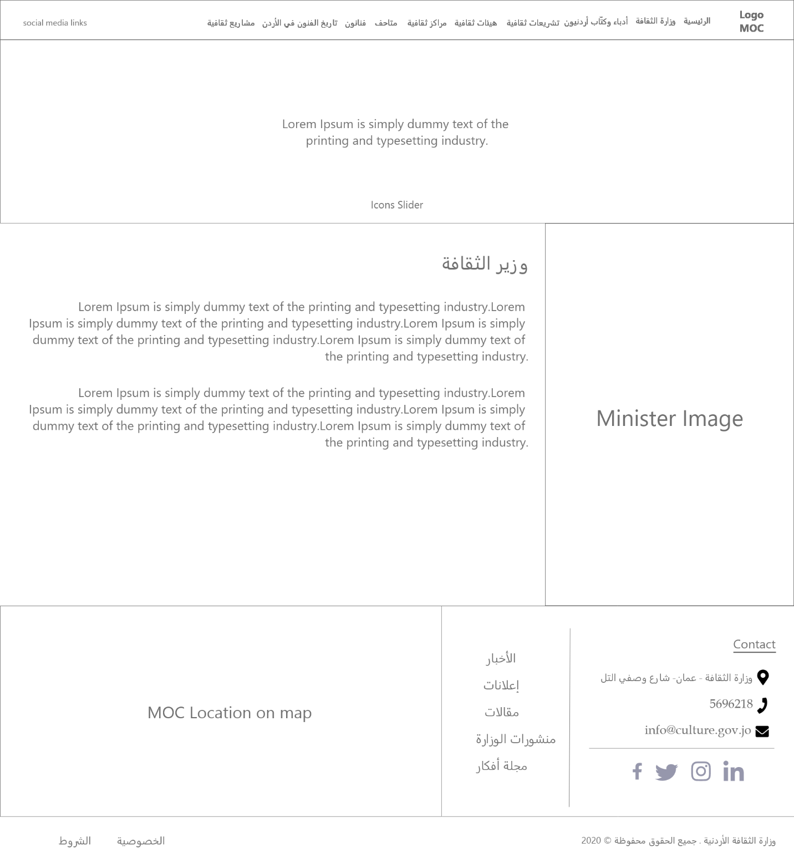

Figure : Wireframe - Minister of Culture

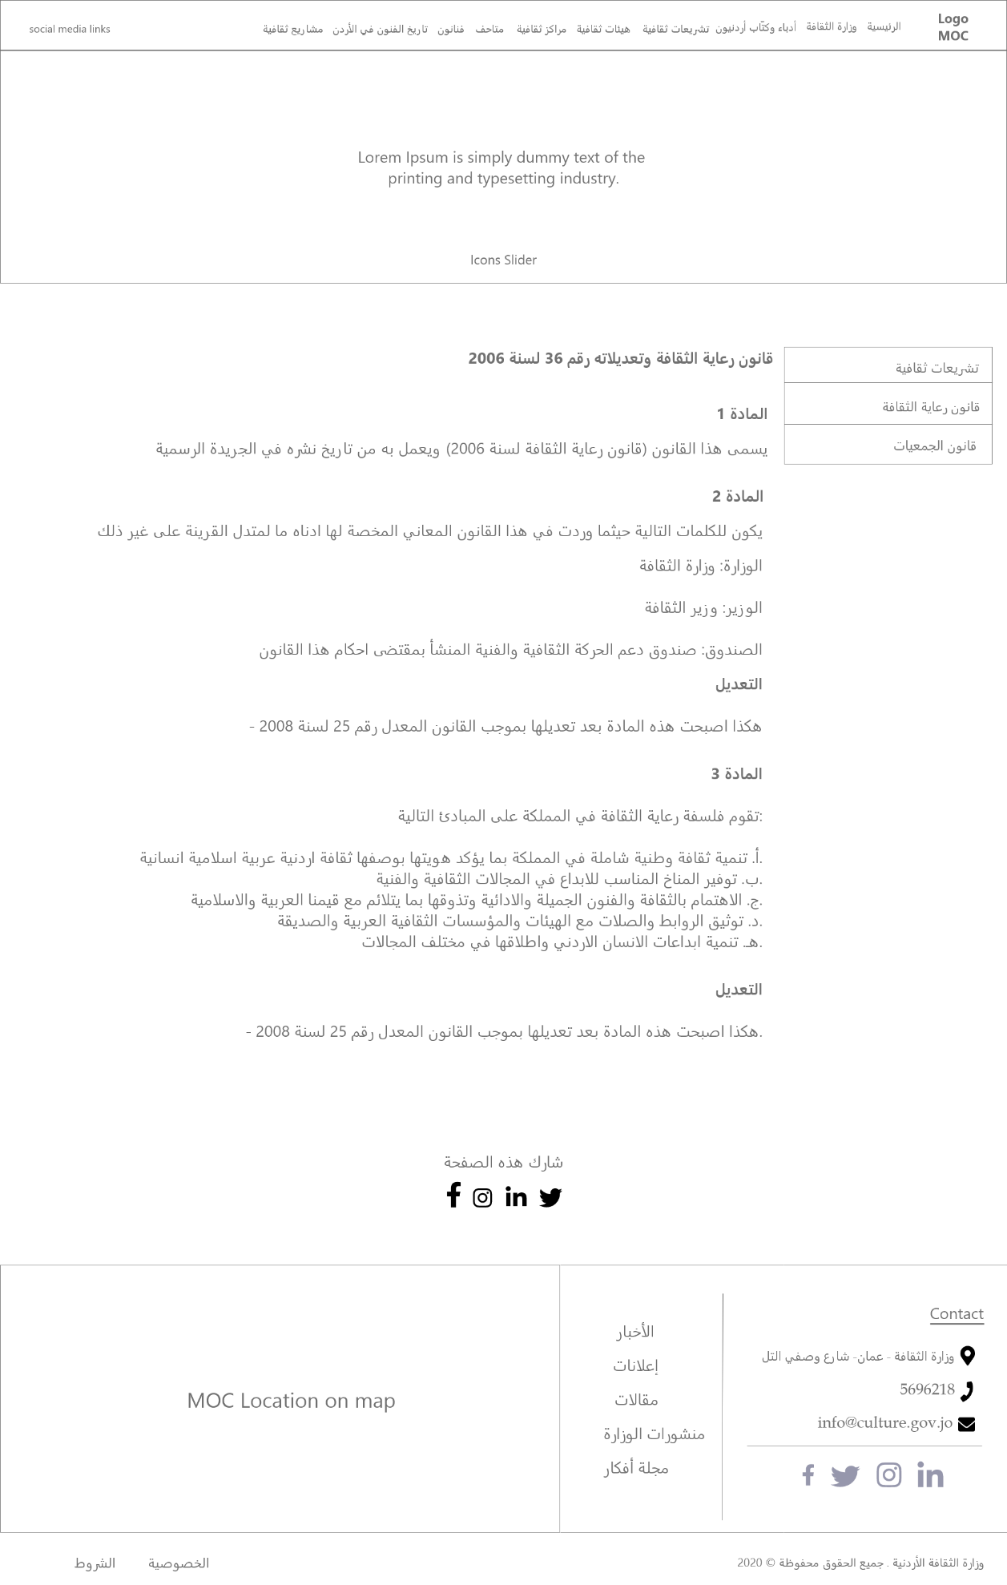

Figure : Wireframe - Culture Care Law

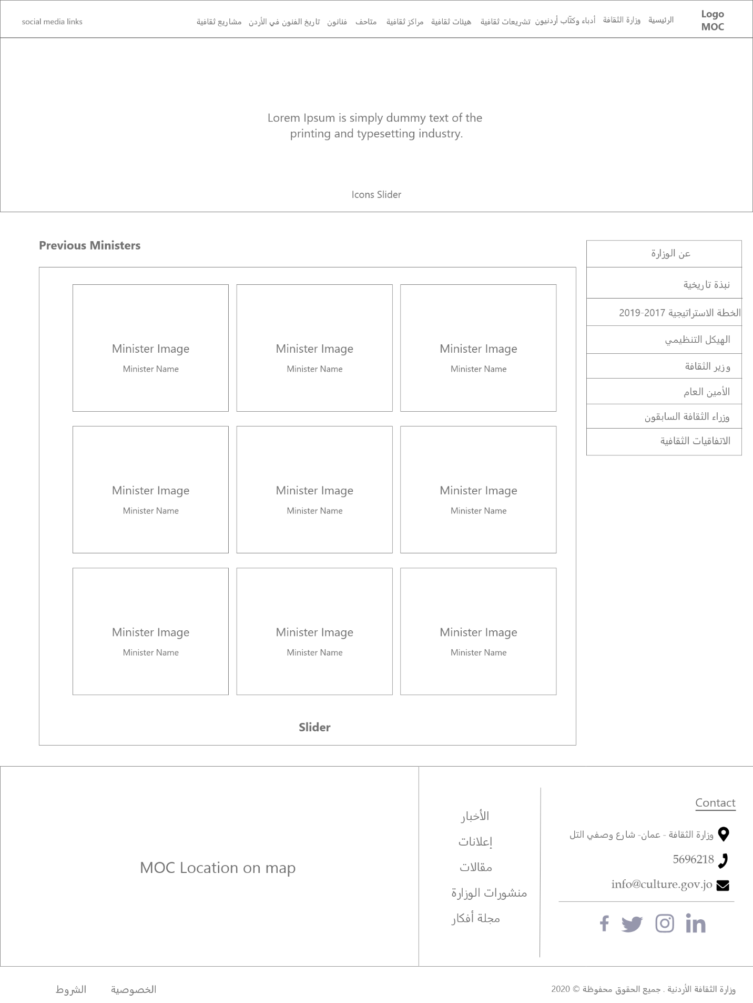

Figure : Wireframe - Prev ministers

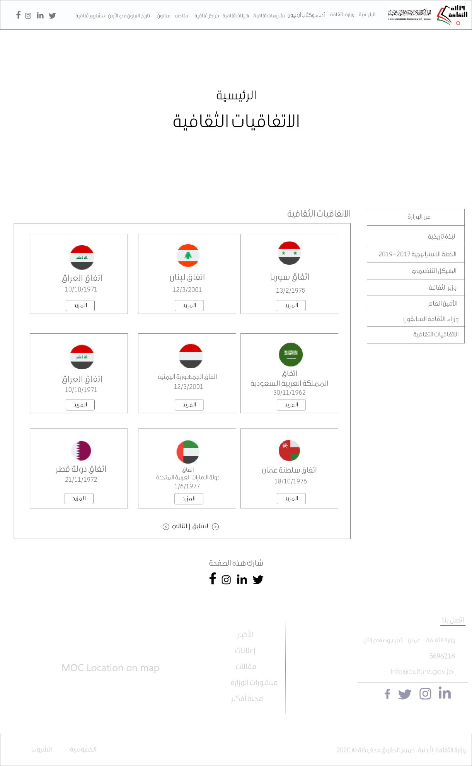

Figure : Wireframe - Cultural agreements

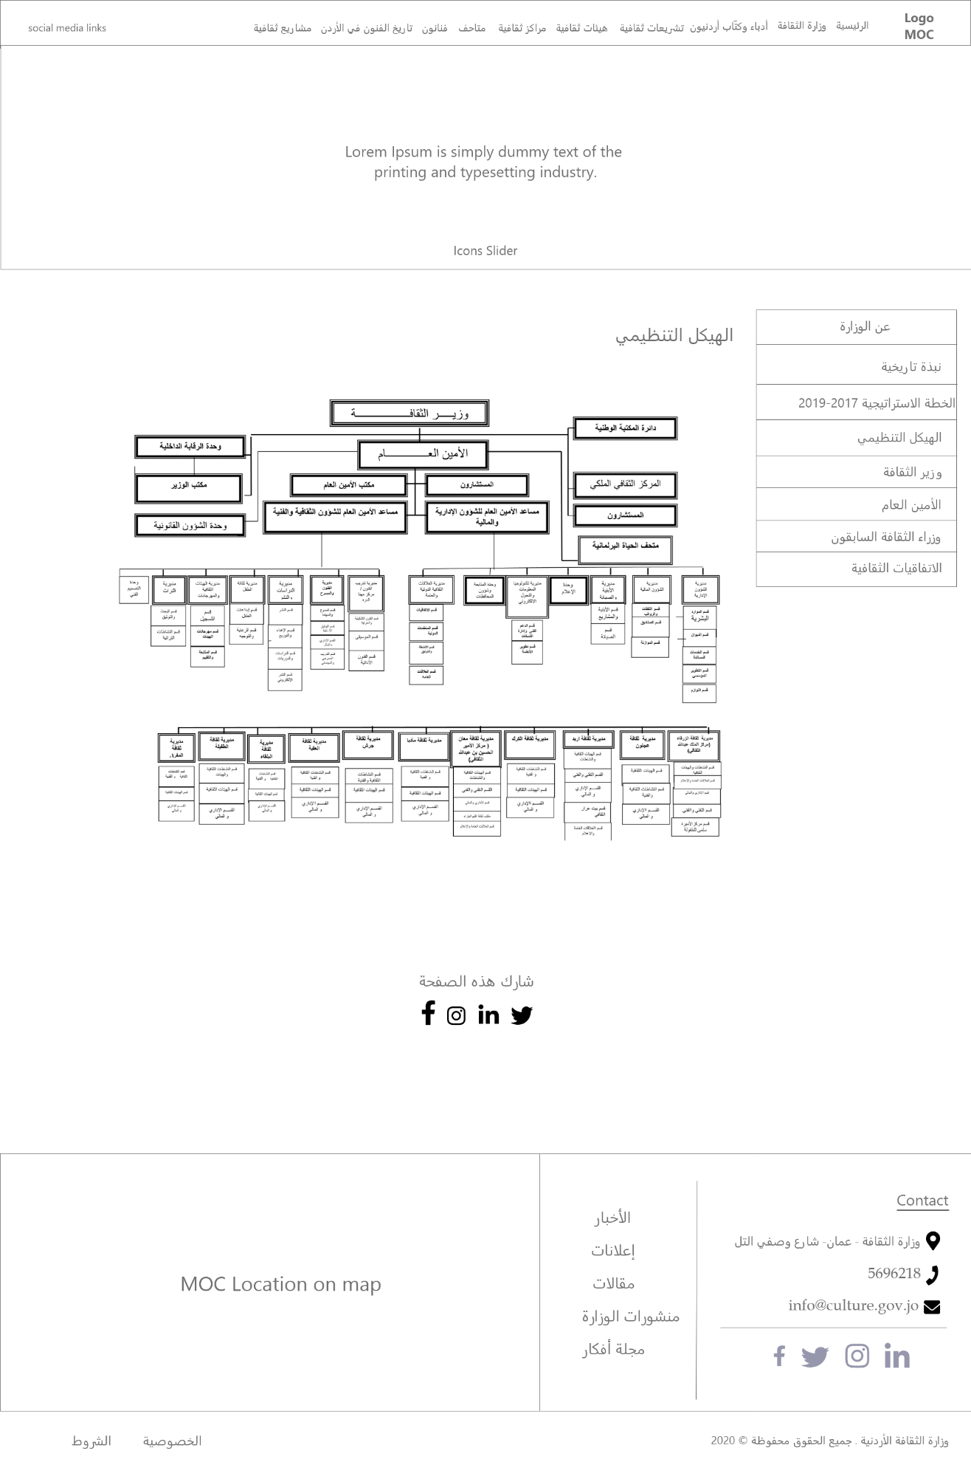

Figure : Wireframe - organizational chart



Figure : Wireframe - Strategic plan

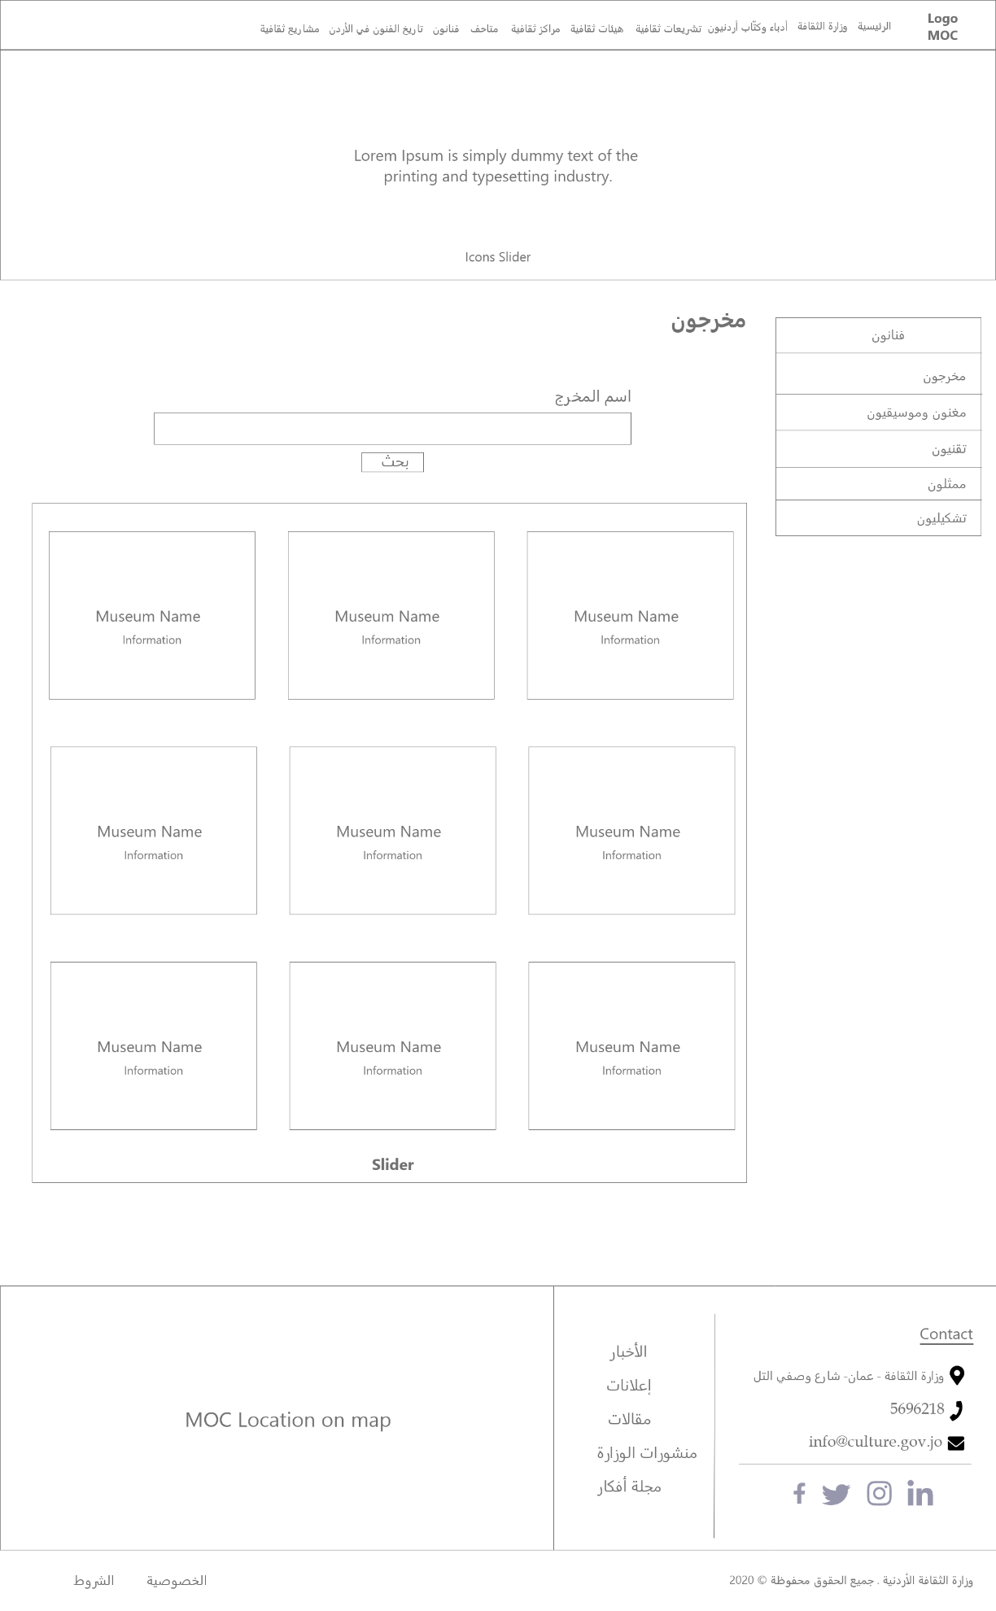

Figure : Wireframe - Directors

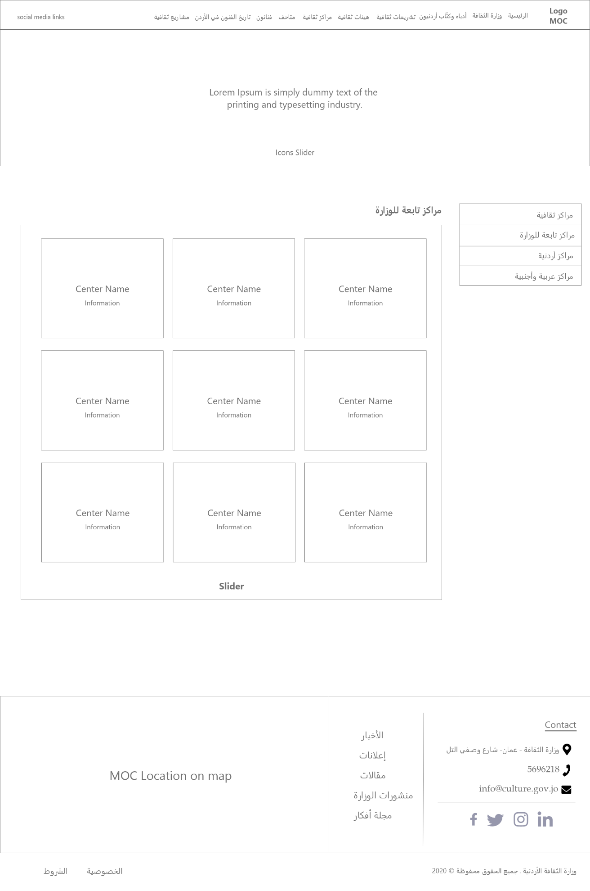

Figure : Wireframe - Cultural centers

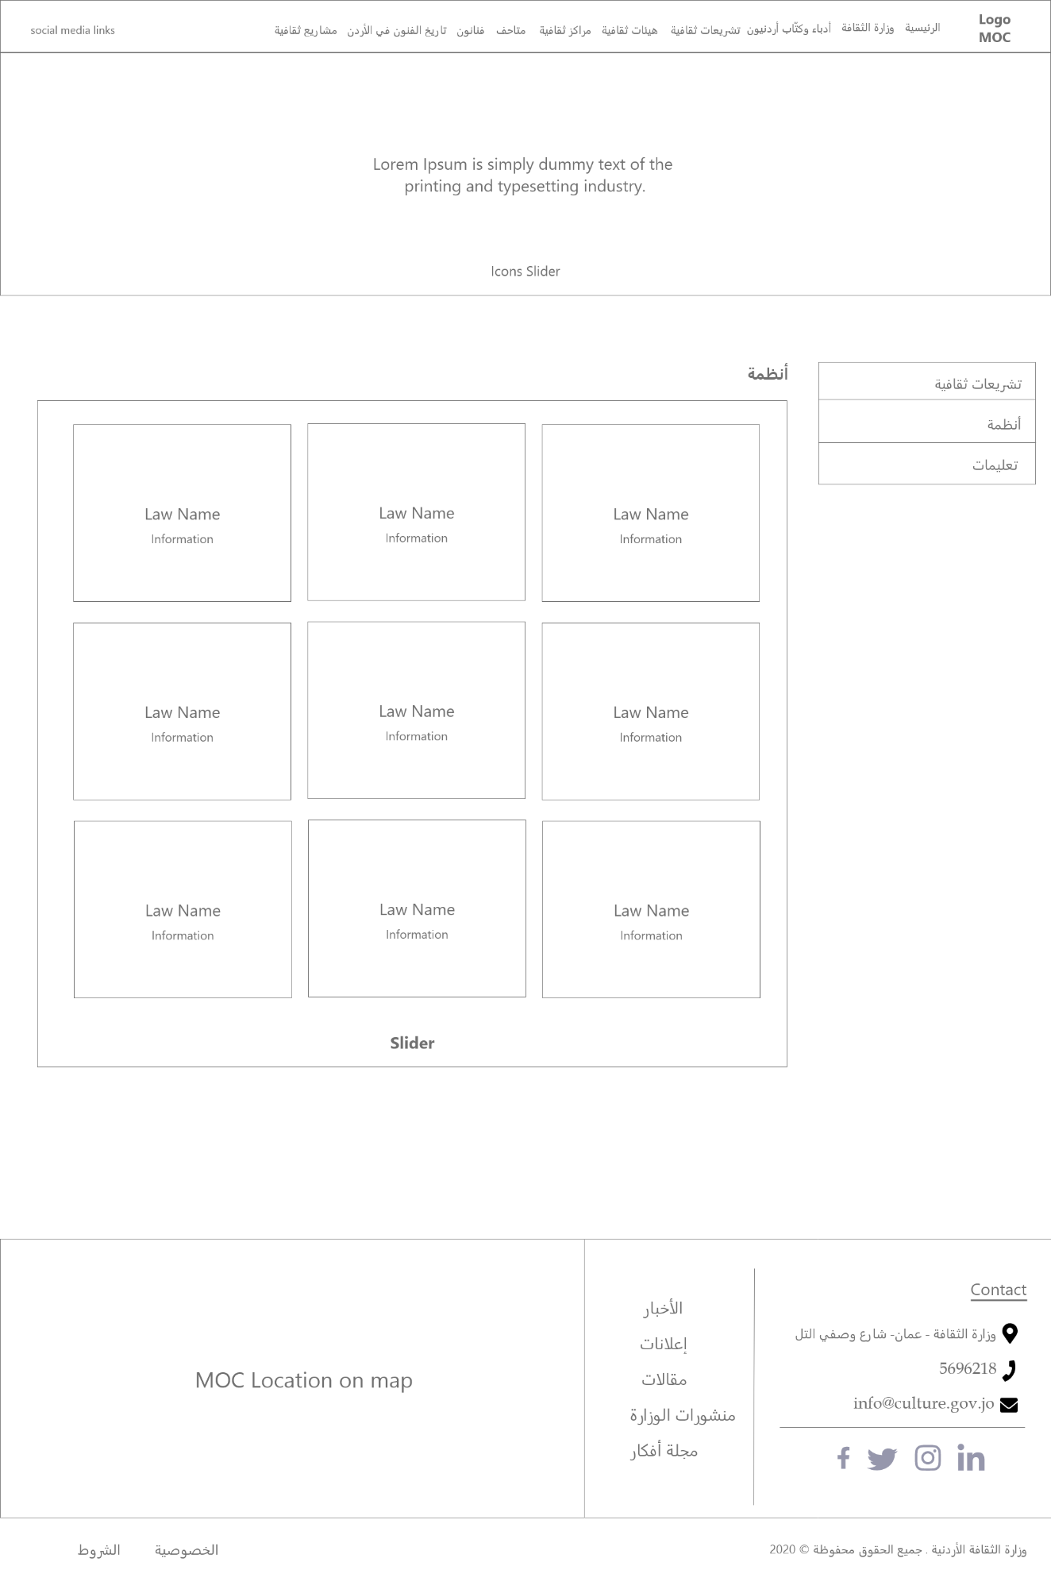

Figure : Wireframe - Systems

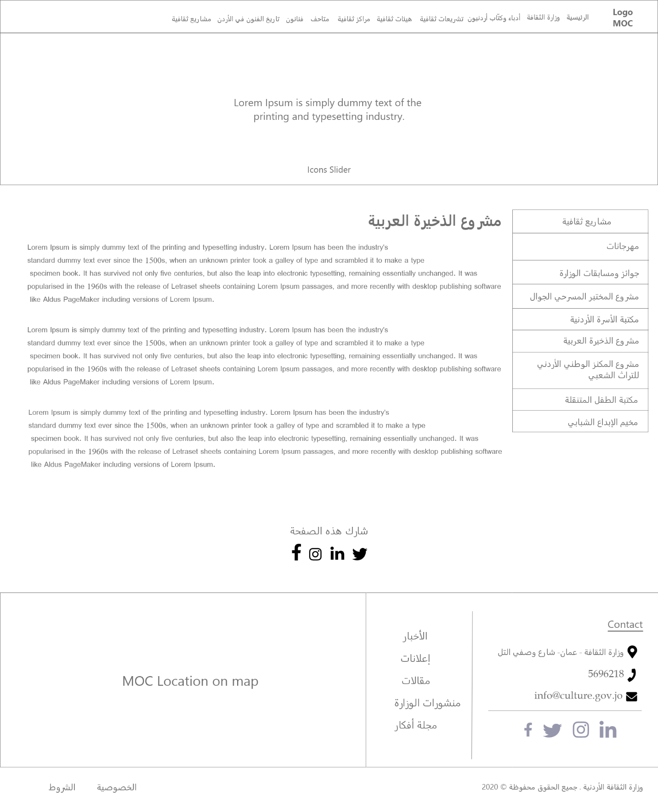

Figure : Wireframe - Arab ammo project

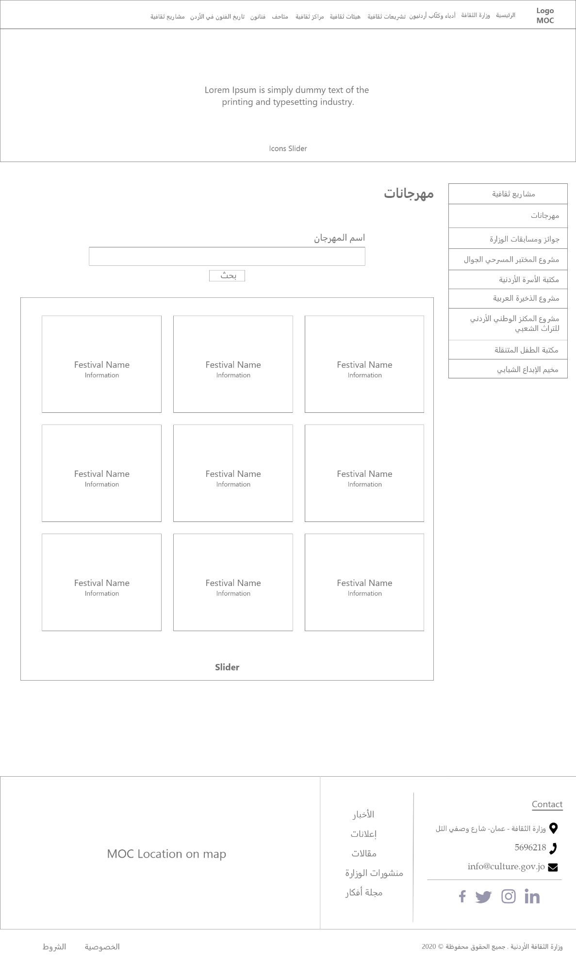

Figure : Wireframe - Festivals

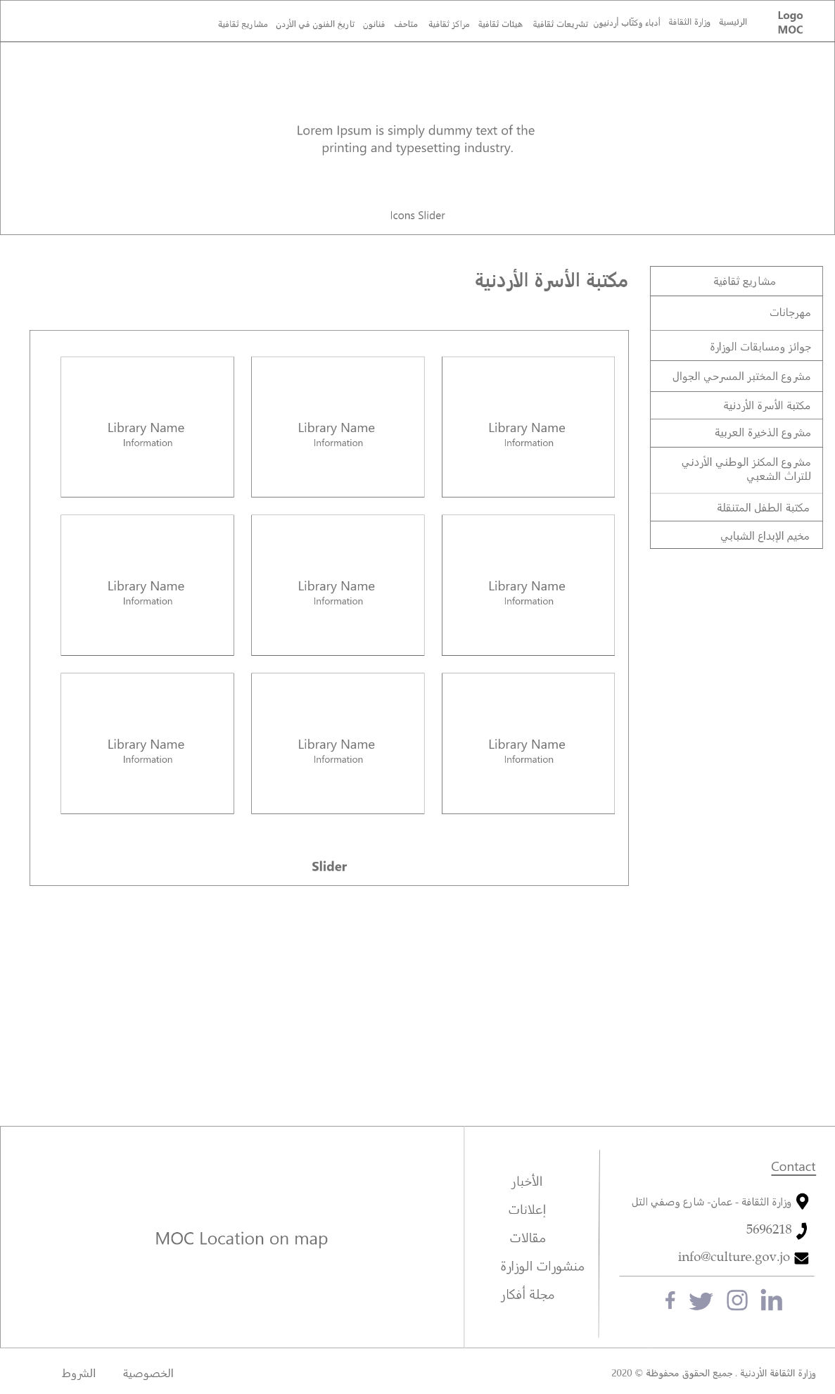

Figure : Wireframe - Jordan family library

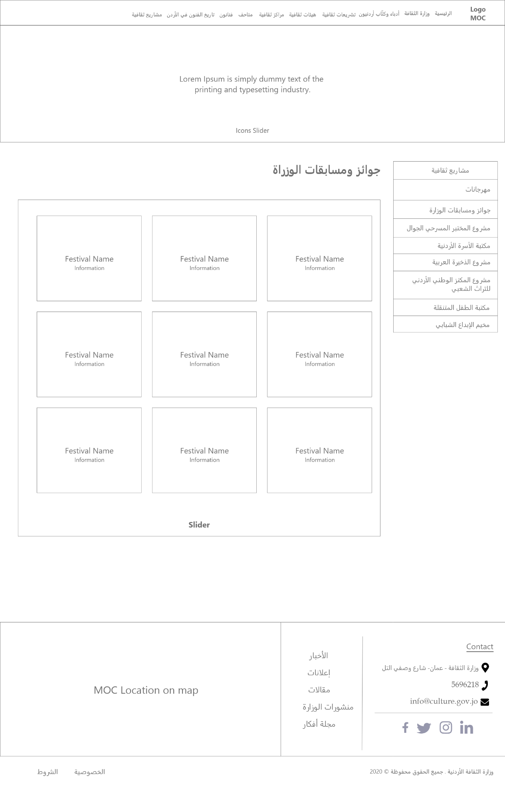

Figure : Wireframe - Ministry prizes

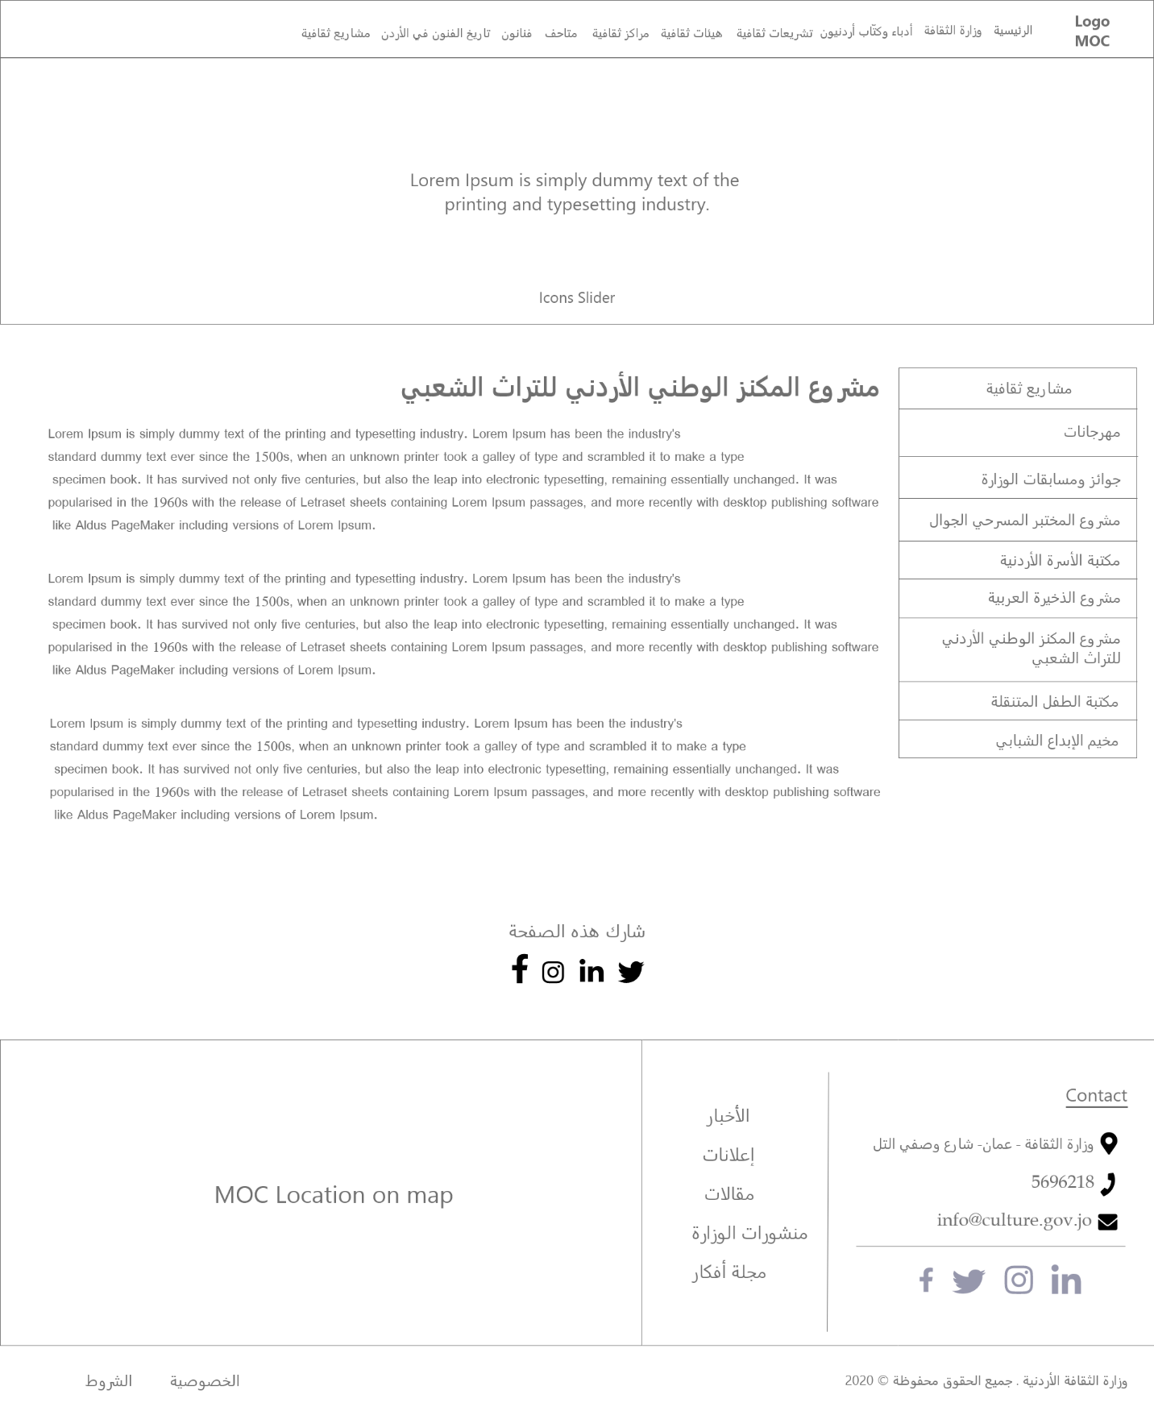

Figure : Wireframe - The Jordanian National Thesaurus for Folklore Project

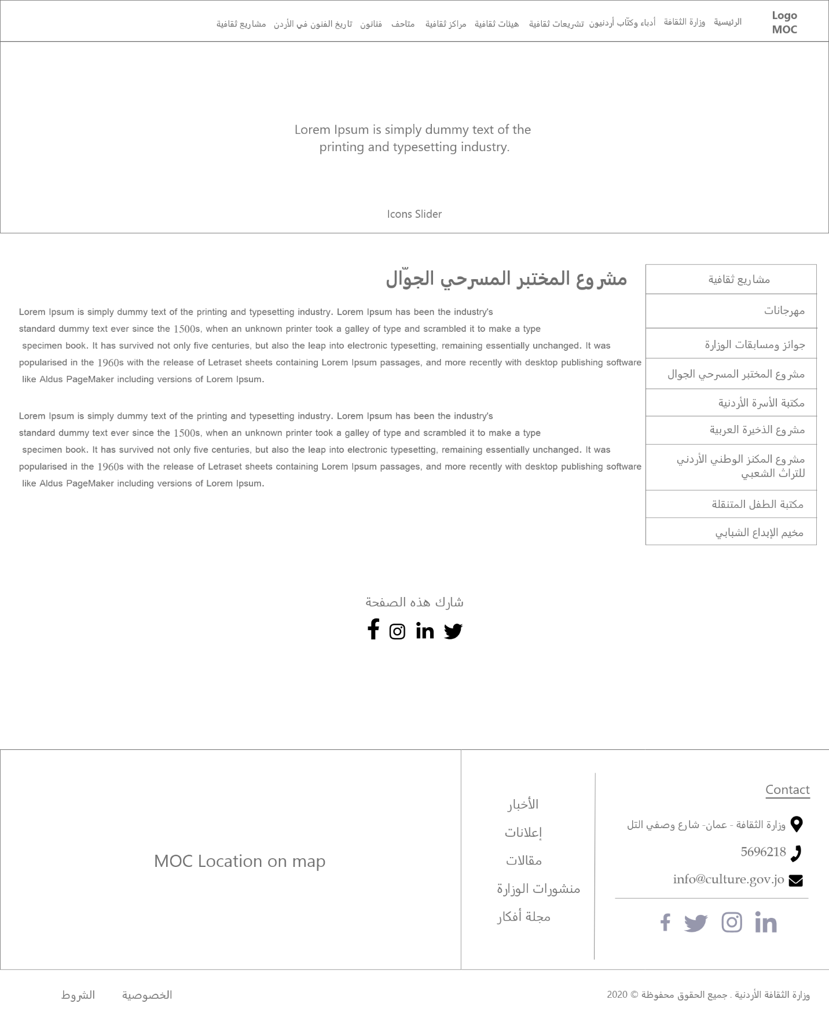

Figure : Wireframe - The Mobile Theater Laboratory Project

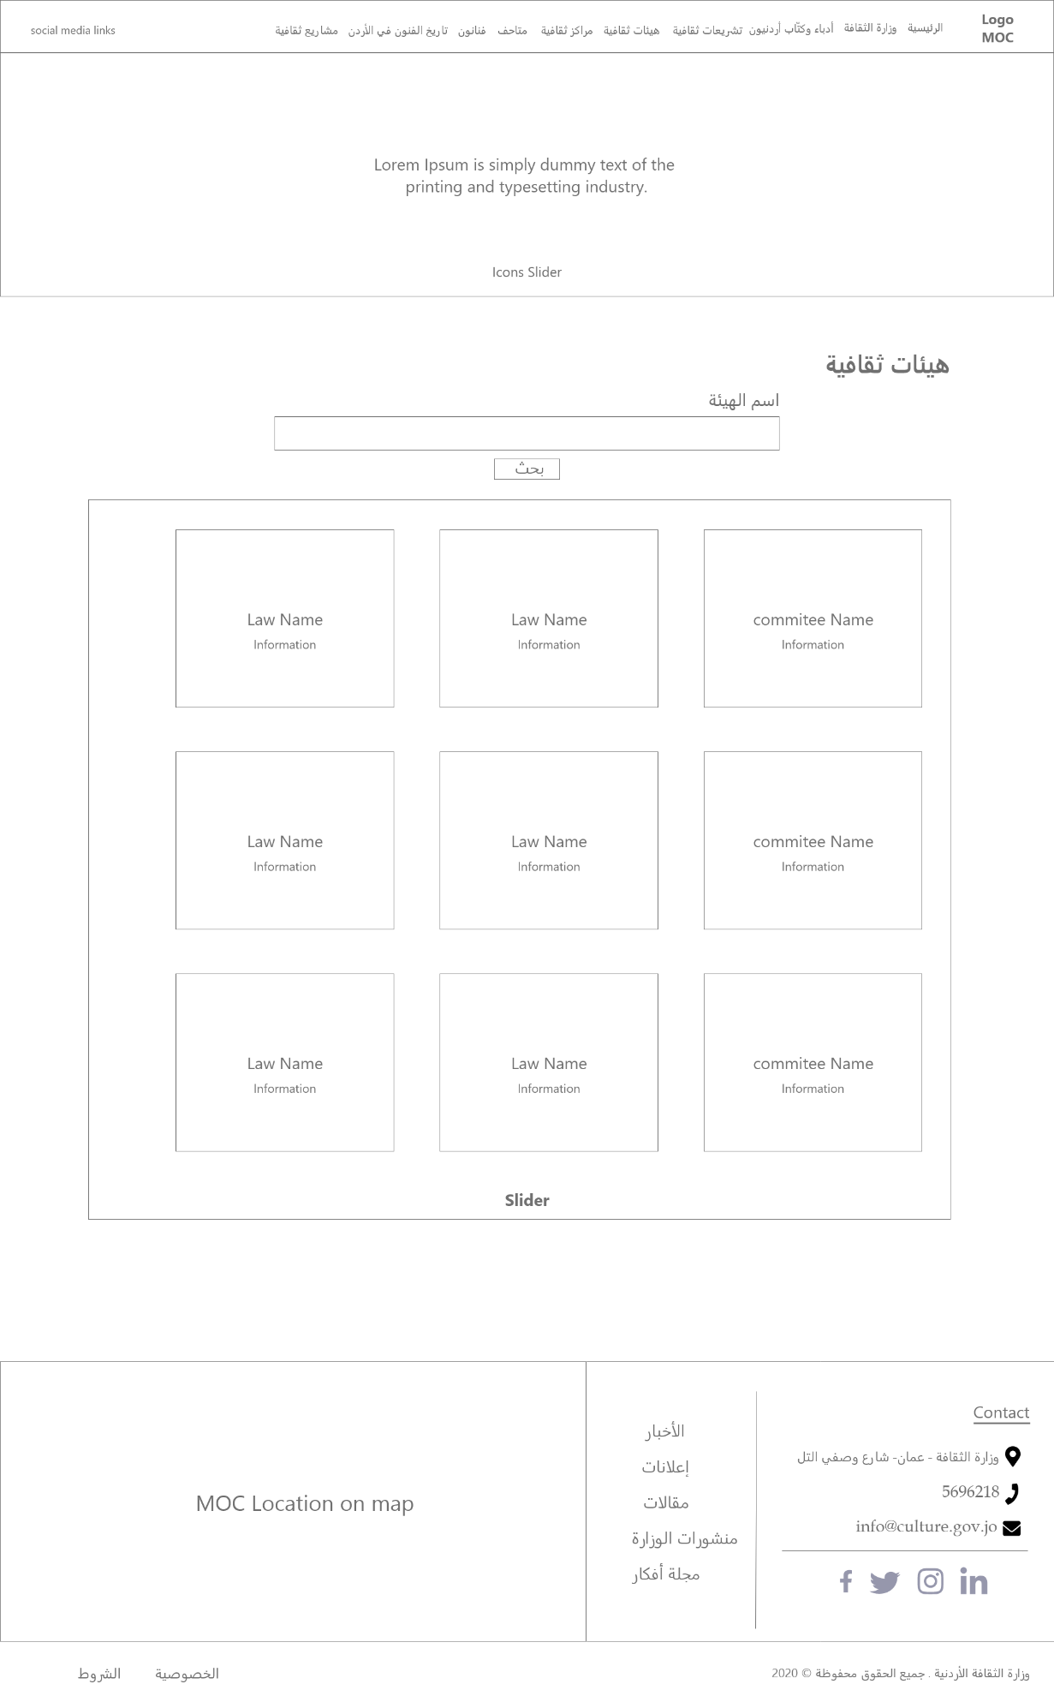

Figure : Wireframe - Cultural-Committees

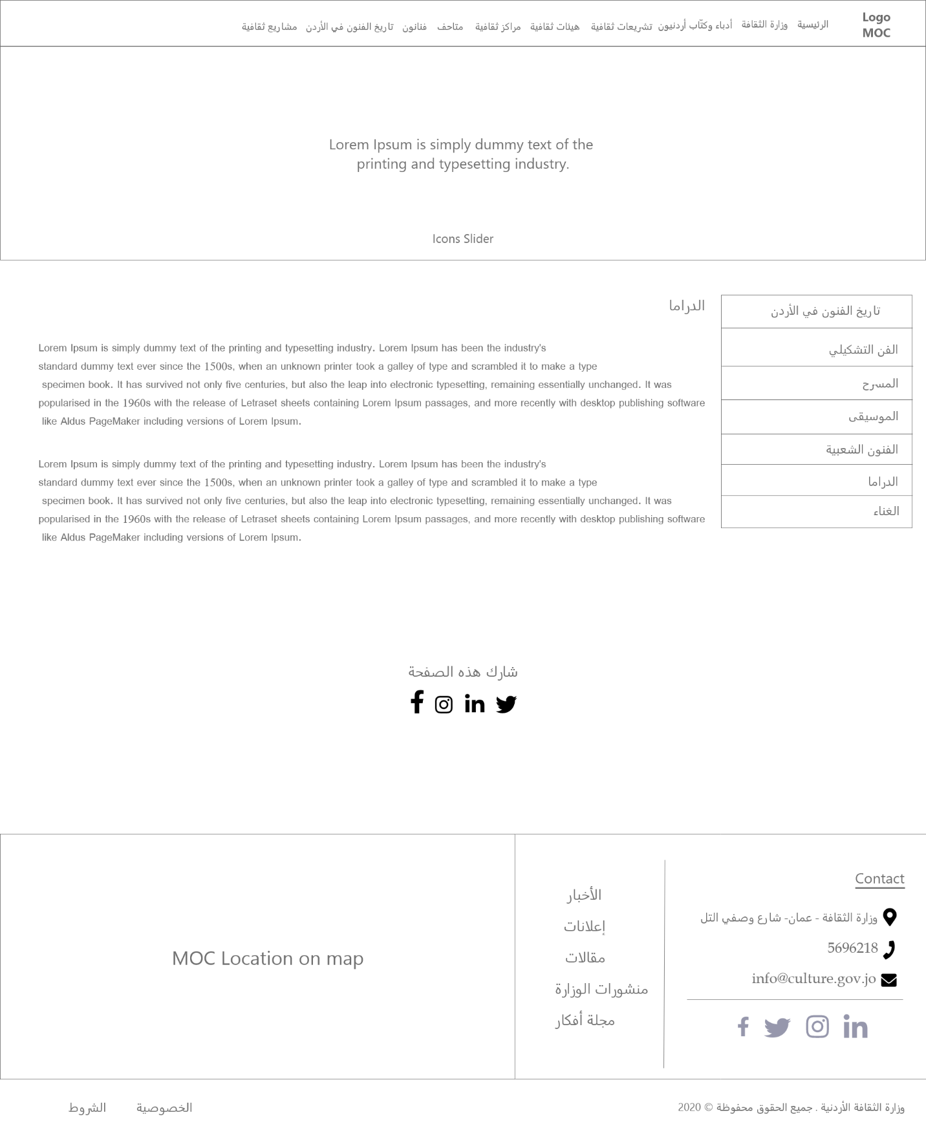

Figure : Wireframe - Drama

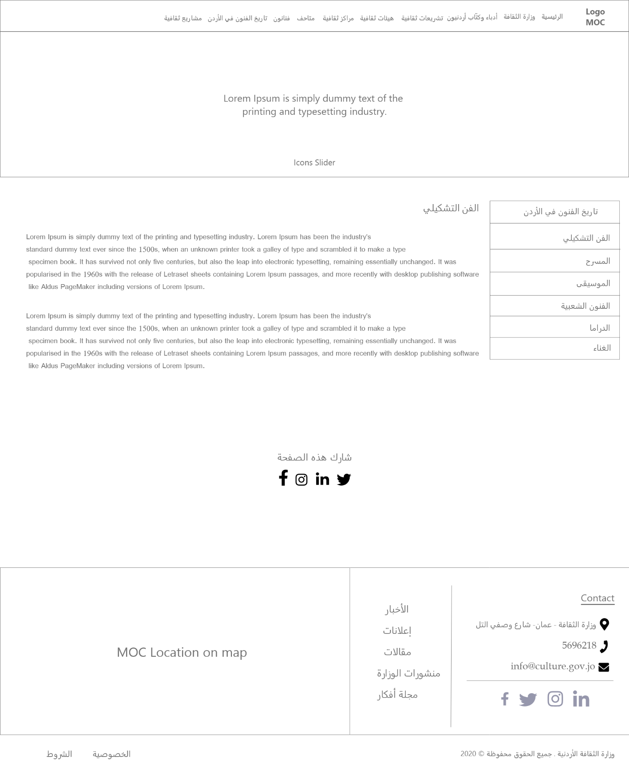

Figure : Wireframe - Fine art

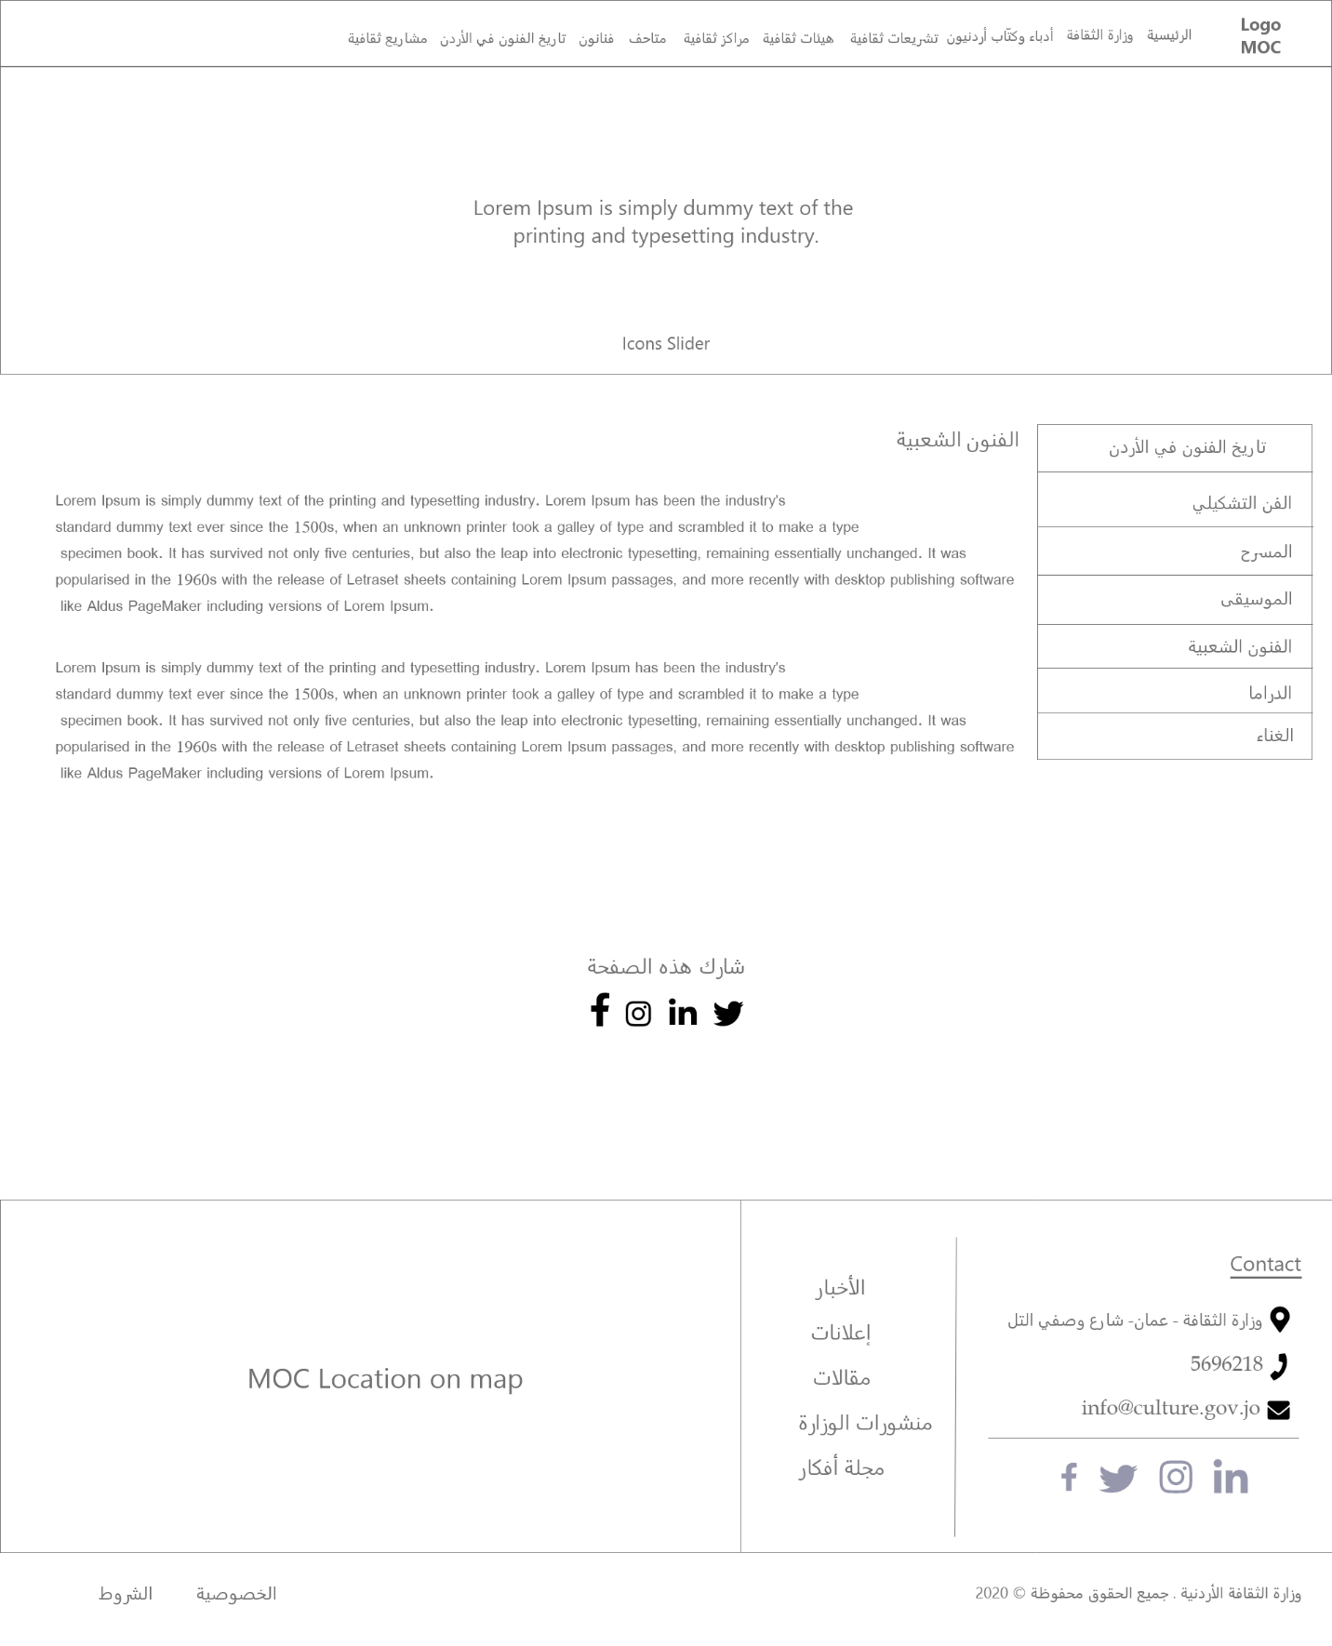

Figure : Wireframe - Folk art

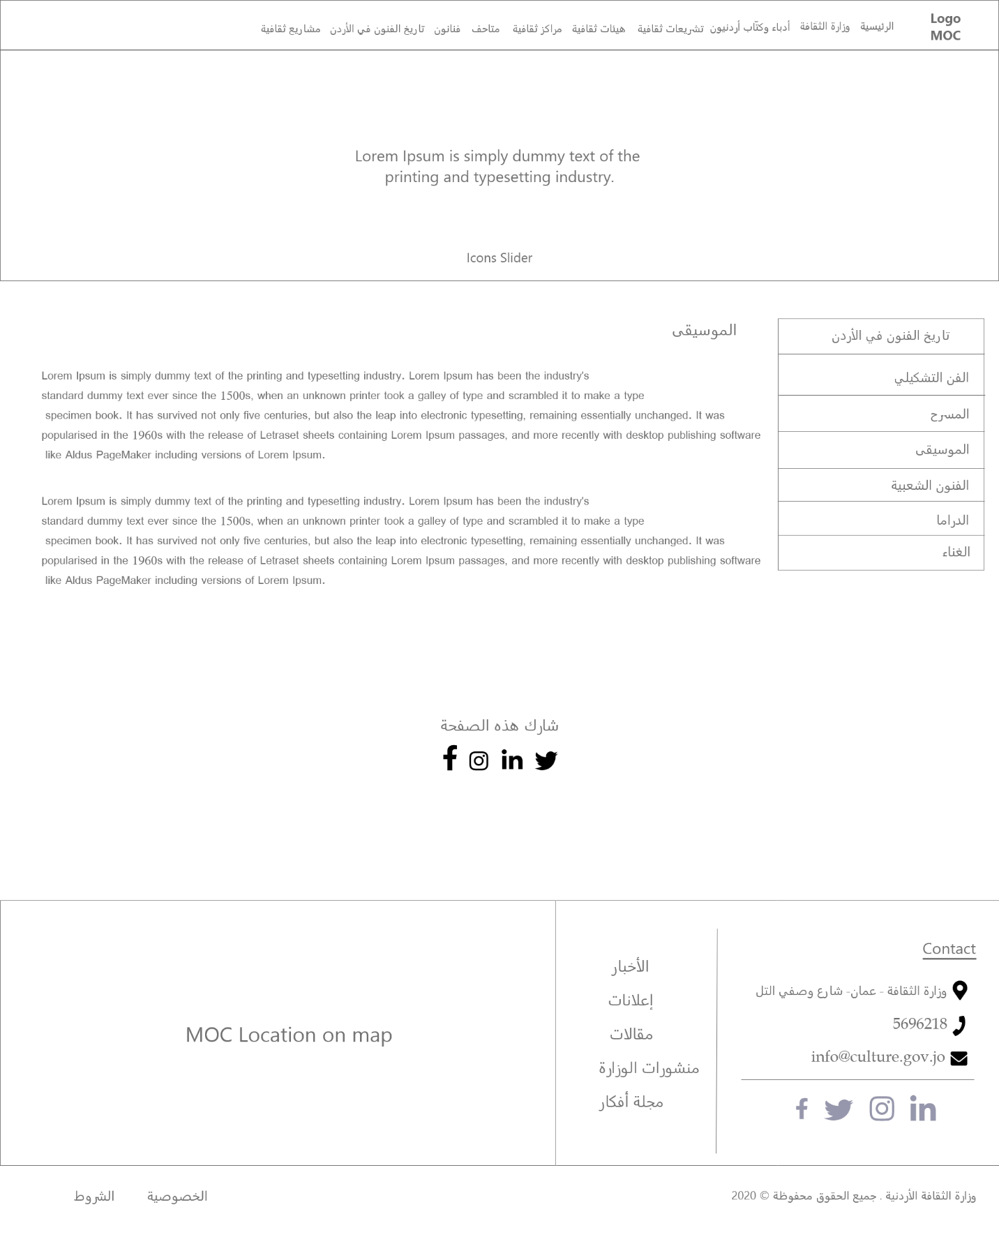

Figure : Wireframe - Music

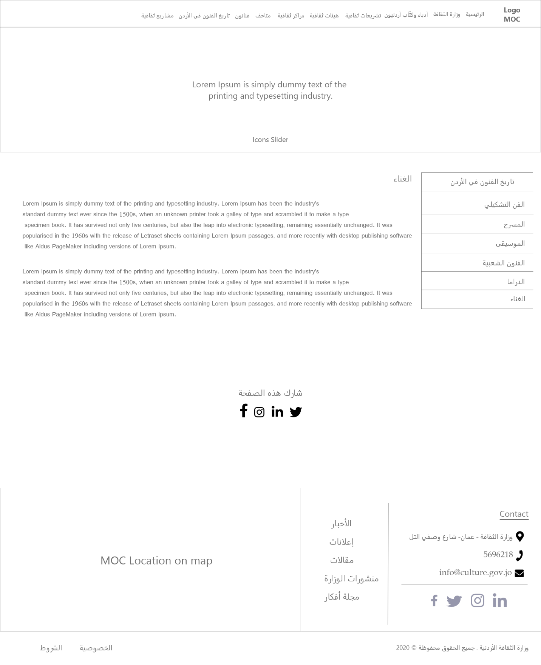

Figure : Wireframe - Singing

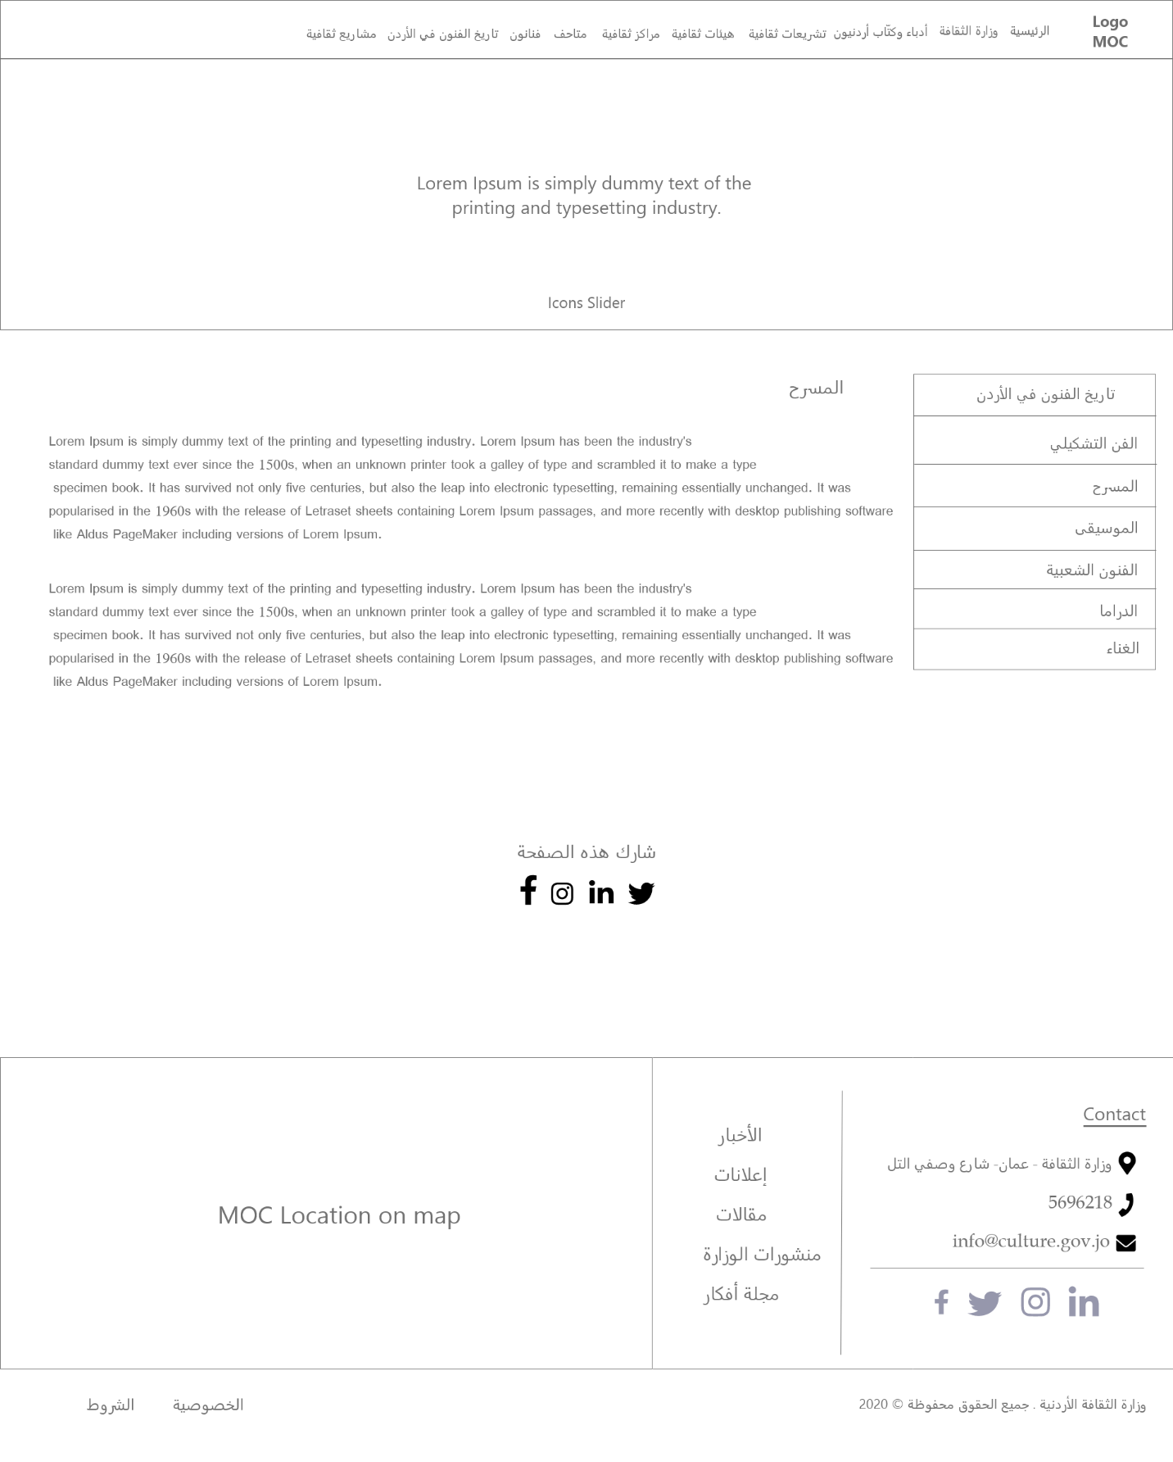

Figure : Wireframe - The Theater

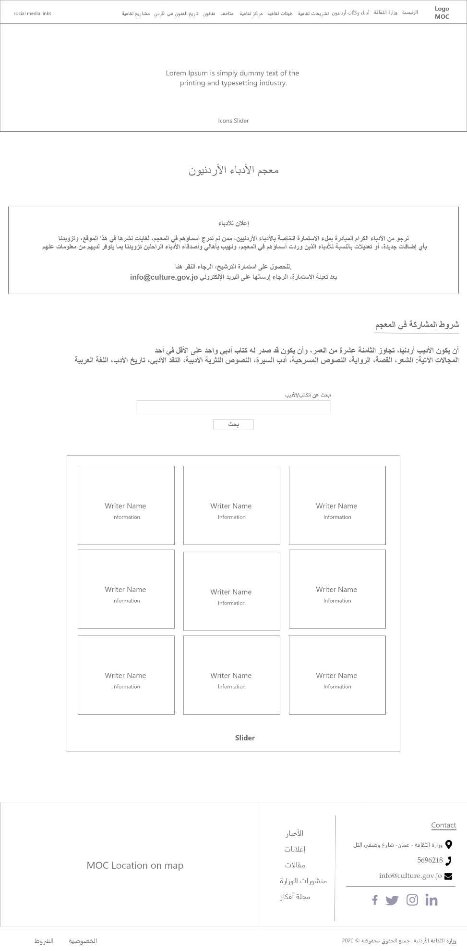

Figure : Wireframe - Jordanian writers

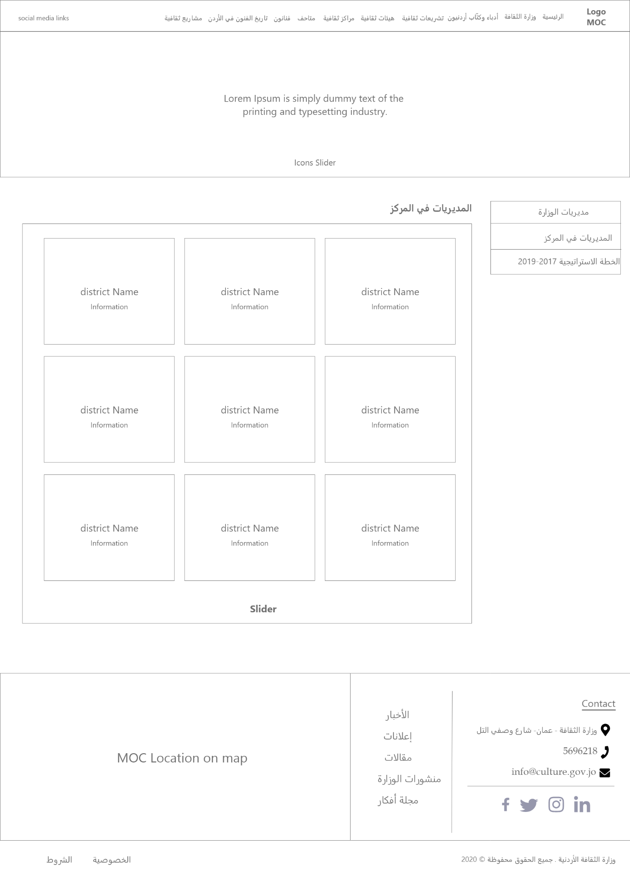

Figure : Wireframe - Directories

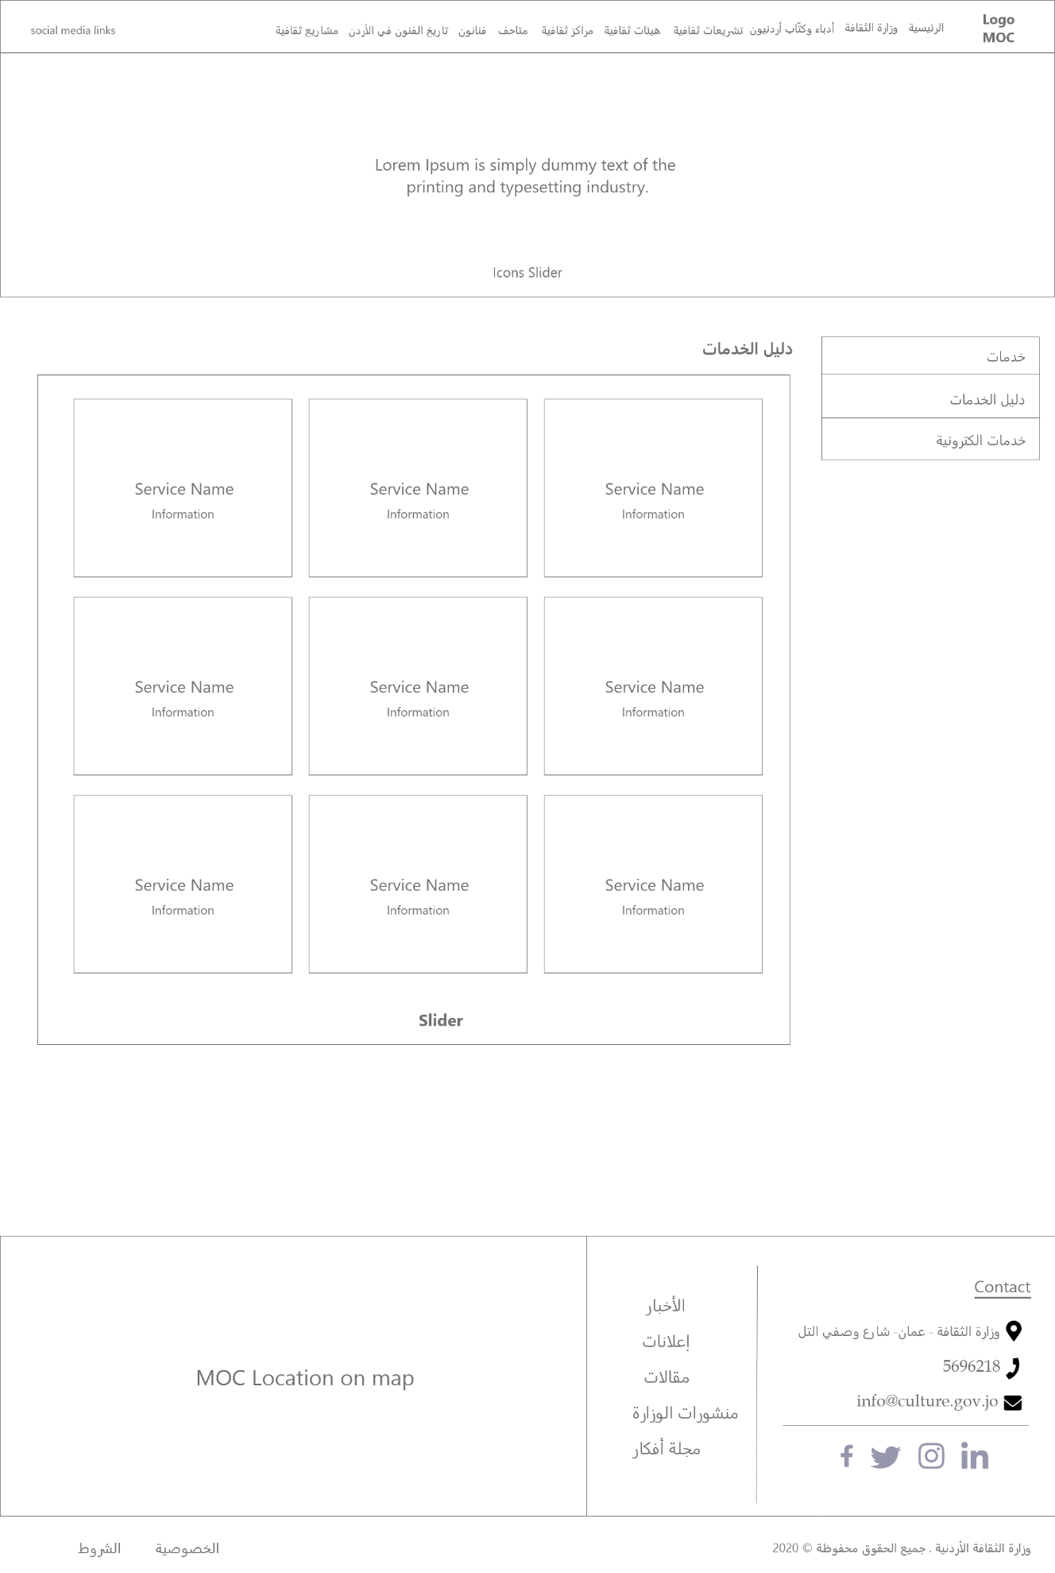

Figure : Wireframe - Services

* **Mockup:** A website mockup is a high-fidelity simulation of how a website will look. Website mockups combine the structure and logic of a wireframe but with the images, graphics, and UI elements that the final product will have.

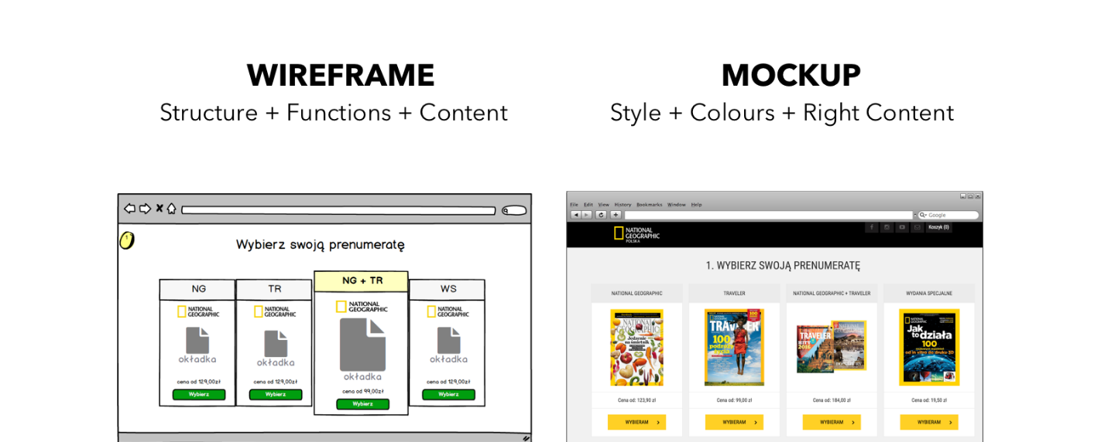

Figure : Wireframe VS Mockup

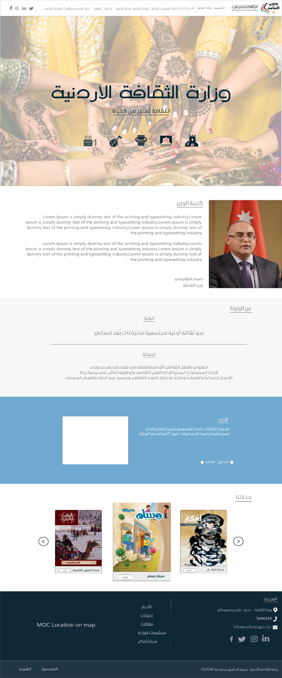

Figure : Mockup - Home page

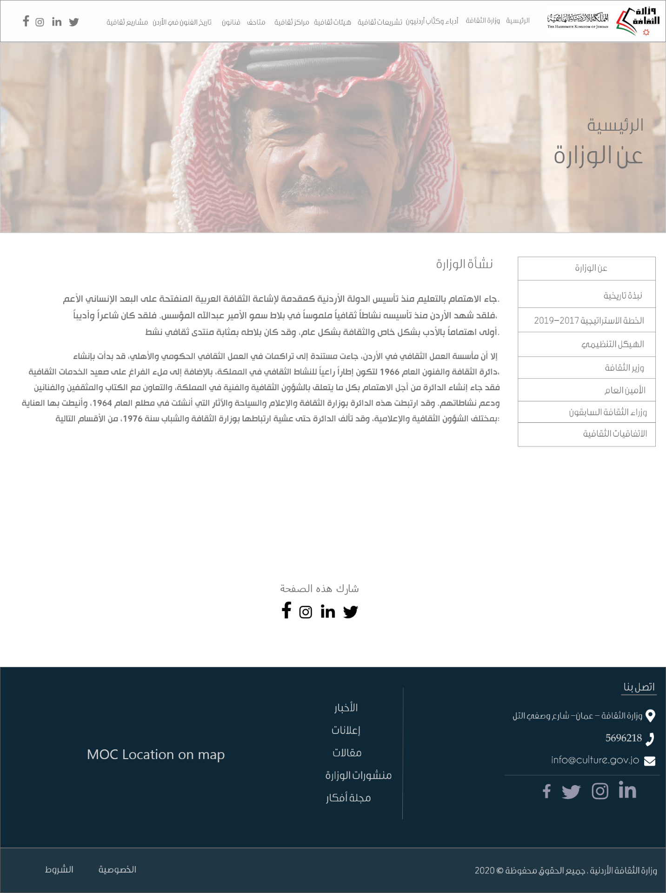

Figure : Mockup - About ministry

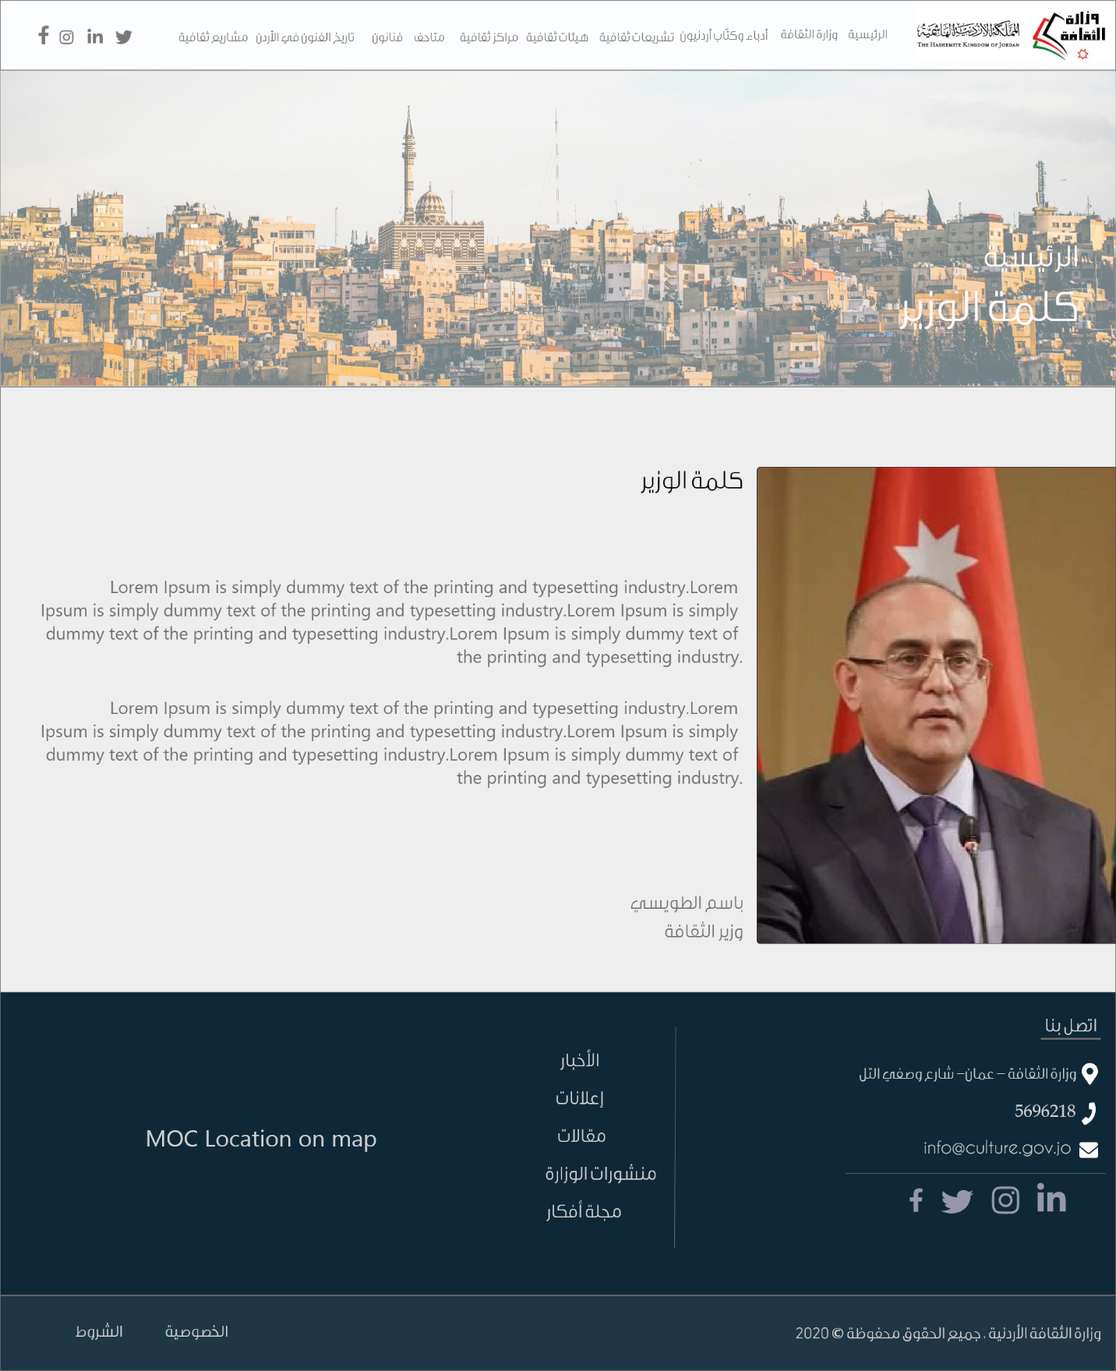

Figure : Mockup - Minister of Culture:

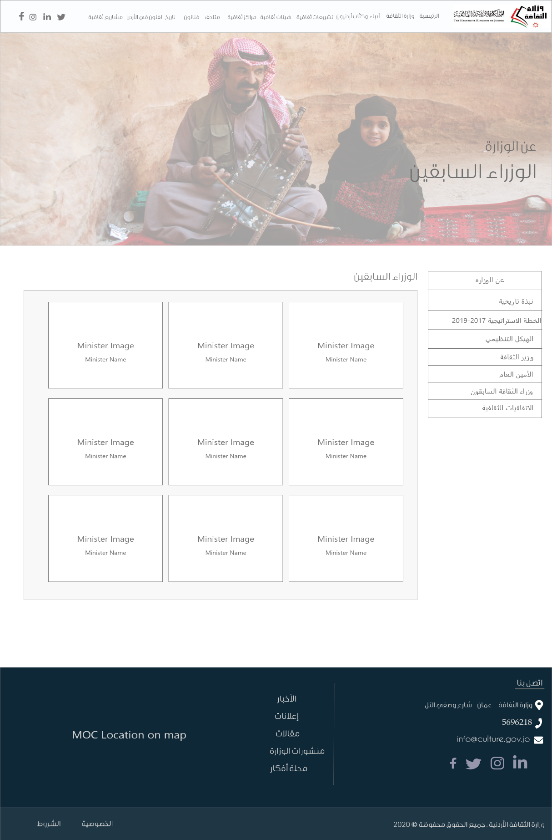

Figure : Mockup - Perv. Ministers

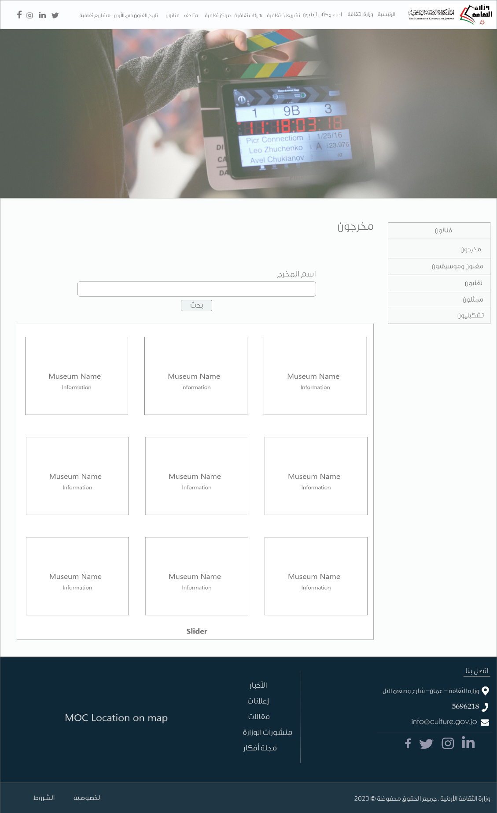

Figure : Mockup - Directors

* **ERD (Entity Relationship Diagram):**



Figure : ERD - Service1



Figure : ERD - Service2



Figure : ERD - Service3



Figure : ERD - Service4

## Development:

* **Backend:** Php was used in the backend part of the project. For the e-services, whenever the user submits the service form, all information that had been entered by the user will be handled by php. First step is to check that the connection is established between the web page and the database. Second step is to get the data that the user entered. The last step is to store user’s request into the database.

For the ministry of Culture website, there are two parts of users who can access it:

1. **Normal Users:** This kind of people can access and navigate into the website without the need of any type of authentication.
2. **Admins:** The admins are responsible about managing the content of the website, such as: news, articles, images, videos, etc. All admins must have a username and password so they can access the CMS (Content Management System).

Normal users can access the e-services on the website without the need to have a username in the database. They can select any service the want to access, filling the service form with the required information, and submit the form. After submitting the form, a confirmation message will appear to the user to acknowledge him whether the process has been done successfully, or something went wrong.

In the other side, pre-defined usernames and passwords are giving to each admin of the system. The admin enters his credentials and the system will check if the username is existing in the database or not. If it exists, the admin will be directed to the dashboard.

## Testing:

In this section, I will mention some test cases that were conducted from the online services and CMS, the cases are as follow:

* **Test Cases:**

|  |  |  |  |  |  |  |  |  |
| --- | --- | --- | --- | --- | --- | --- | --- | --- |
| Test Cases | | | | | | | | |
| **Test case id** | **Component** | **Priority** | **Description** | **Pre-requisites** | **Steps** | **Expected Result** | **Actual Result** | **Status** |
| Website_search | Search bar | P0 | Verify that when a user writes a search term and presses enter, search results should be displayed | Browser is launched | 1. Write the url - http://culture-jo.tech/home in the browser's URL bar and press enter.  2. Once website is launched, write the search term - "culture" in the google search bar.  3. Press enter. | The ministry website will be displayed on the screen. | The ministry website will be displayed on the screen. | Pass |
| Admin_login | CMS login form | P0 | Verify when the admin enters his username and password and press on the login button, he will be redirect to the CMS dashboard | Admin username and password must be stored in the database | 1. Admin enters his username. 2. Admin enters his password. 3. Admin click on the submit button. | The admin should be redirected to the CMS dashboard | The admin should be redirected to the CMS dashboard | pass |

|  |  |  |  |  |  |  |  |  |
| --- | --- | --- | --- | --- | --- | --- | --- | --- |
| Book_  National_stage | National stage booking service form | P0 | Allow the user to book the national stage on a certain date | User is on the ministry of culture website | 1. User enter the required information into the service form.  2. User click on the submit button to process his request. | User request is processed successfully, and his information is stored into the database | User request is processed successfully, and his information is stored into the database | pass |
| Book_national  _stage  _training_room | National stage booking service form | P0 | Allow the user to book the national stage training room on a certain date | User is on the ministry of culture website | 1. User enter the required information into the service form.  2. User click on the submit button to process his request. | User request is processed successfully, and his information is stored into the database | User request is processed successfully, and his information is stored into the database | pass |
| Buy_book | Buy book service form | P0 | Allow user to buy any book online form this service | User is on the ministry of culture website | 1. User enter the required information into the service form.  2. User click on the submit button to process his request. | User request is processed successfully, and his information is stored into the database | User request is processed successfully, and his information is stored into the database | pass |

|  |  |  |  |  |  |  |  |  |
| --- | --- | --- | --- | --- | --- | --- | --- | --- |
| Add_news | CMS news form | P0 | Verify when the admin adds new news to the website, his request is done, and the data is stored in the database | Admin is logged into the CMS system | 1. Admin enters the news title.  2. Admin enters the news content.  3. Admin choose the news date. | The admin request is received successfully to the server, and the news are added to the database. | The admin request is received successfully to the server, and the news are added to the database. | pass |
| Display_news | CMS news form | P0 | Display all news for a specific date to the admin. | Admin is logged into the CMS system | 1. Admin selects the date which the news is published in.  2. Admin click on submit button. | All news for the date that was selected should be displayed to the admin | All news for the date that was selected should be displayed to the admin | pass |

## Deployment:

The deployment process was divided into two parts:

* **Hosting:** In this part, I used 000webhostapp.com to upload the website’s files and assets on a shared server.

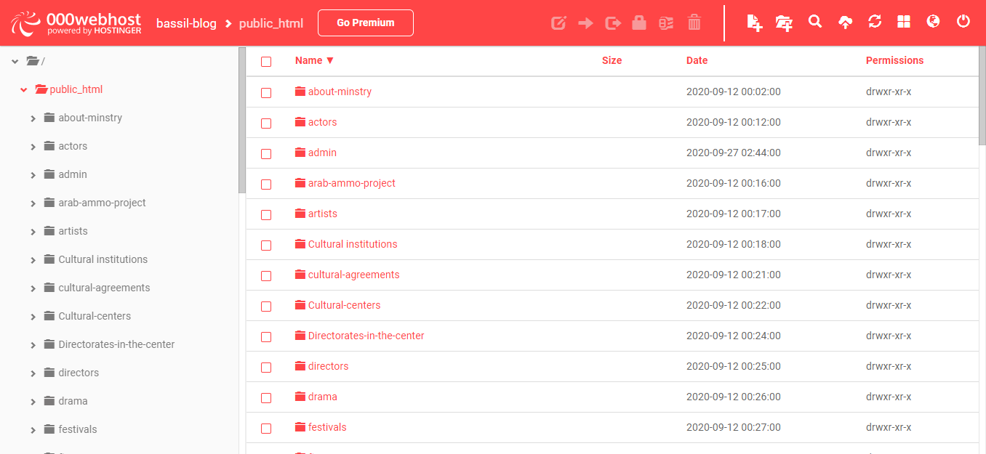

Figure : Hosting website files and assets

* **Domain name:** The domain name for my website is: **culture-jo.tech/home,** it was purchased from **.tech domains.**

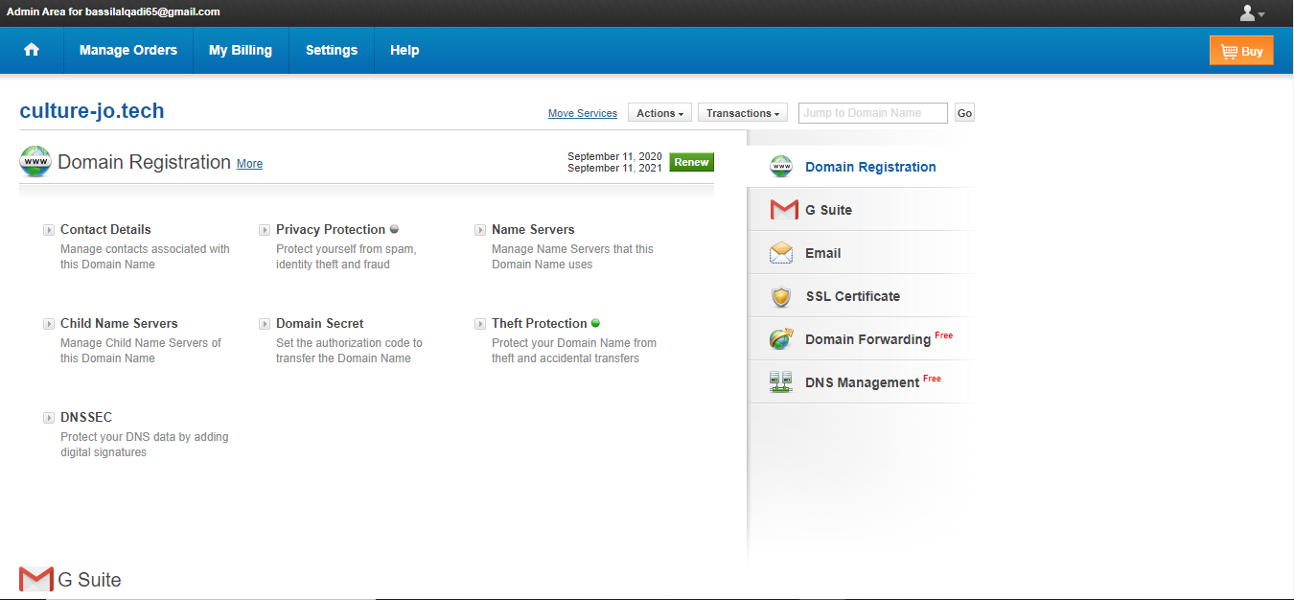

Figure : Website domain name

After the files were uploaded to the server, and the domain name was purchased. A connection between the domain name and the hosting server were established, so whenever a user search for the ministry’s websites(request), the index page is returned to him from the server(response).

# Screenshots:



Figure : Home Page

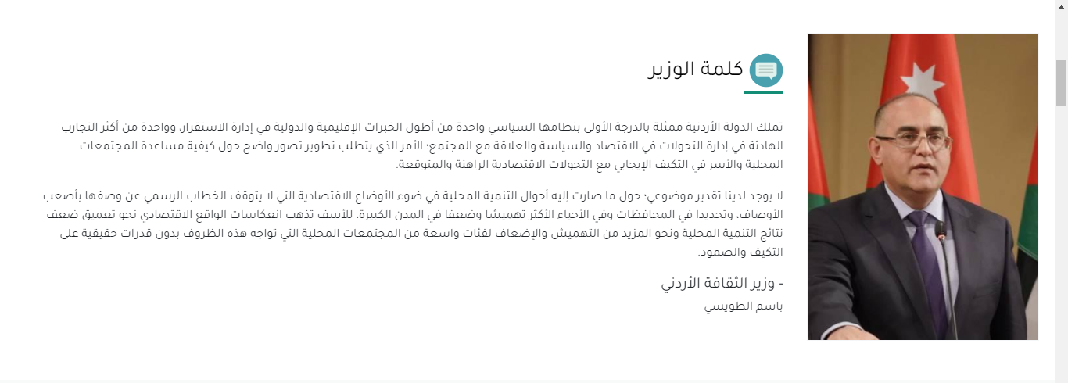

Figure : Minister Word

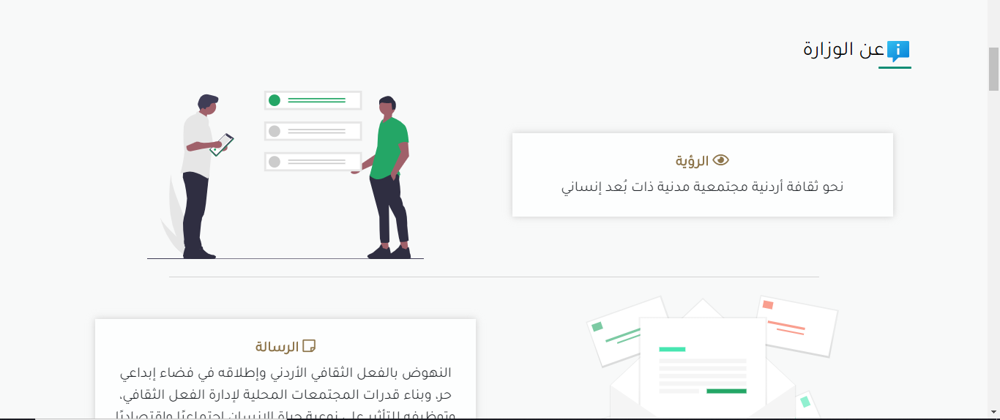

Figure : About the ministry - 1

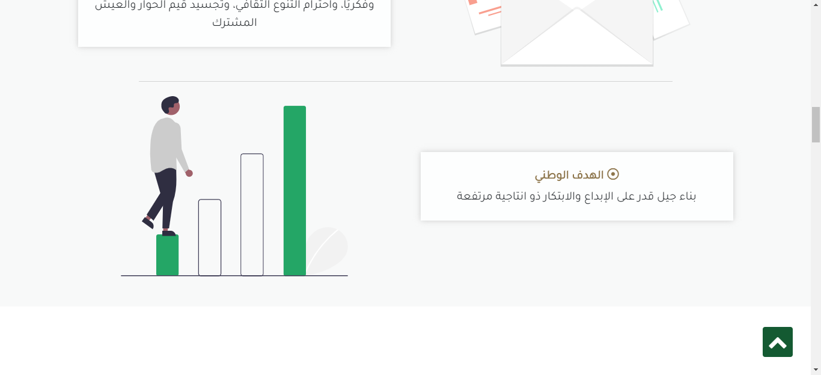

Figure : About the ministry - 2

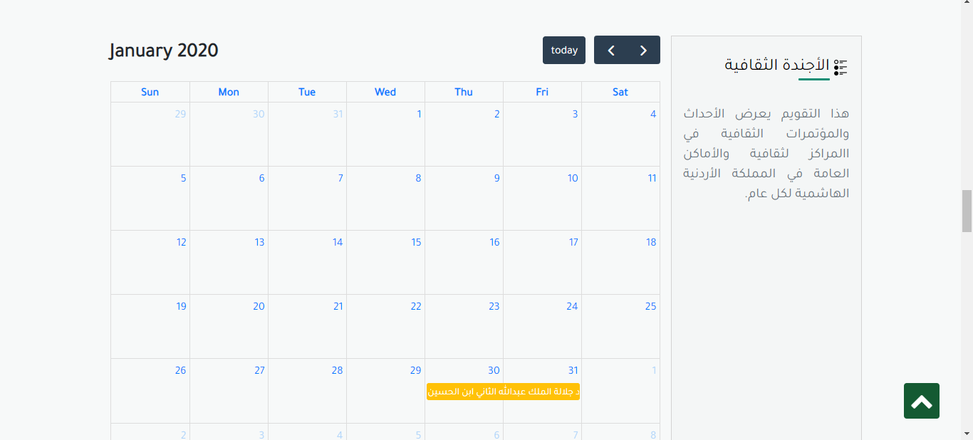

Figure : Cultural event calendar

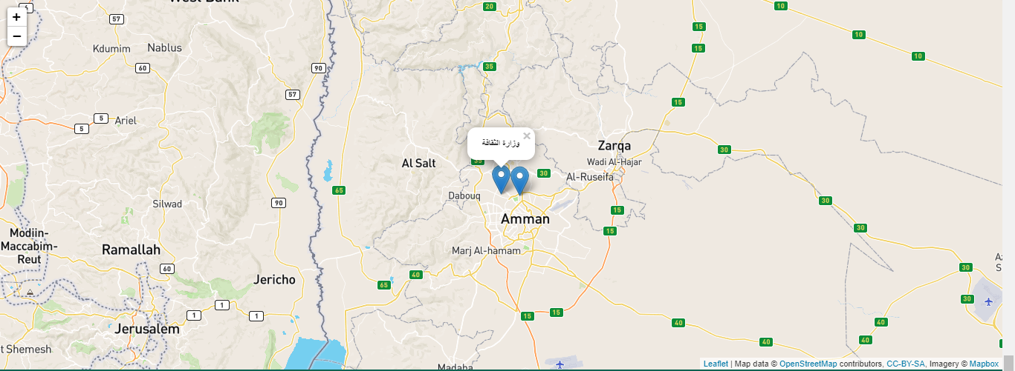



Figure : Footer

Figure : Ministry location

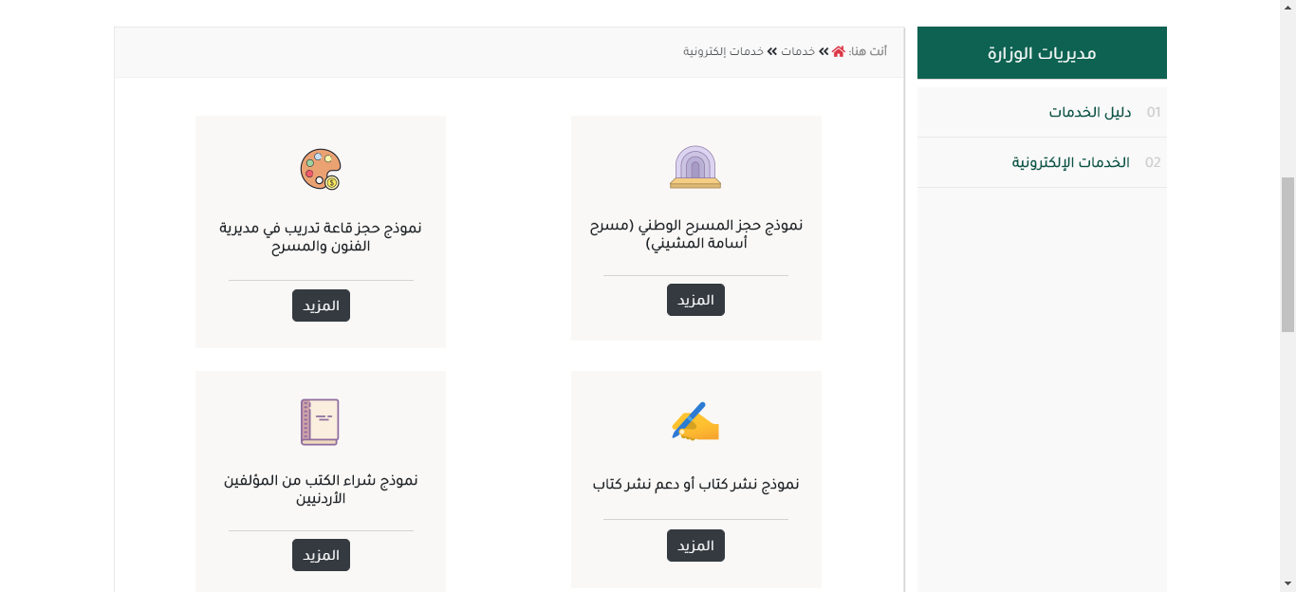

Figure : Services Page

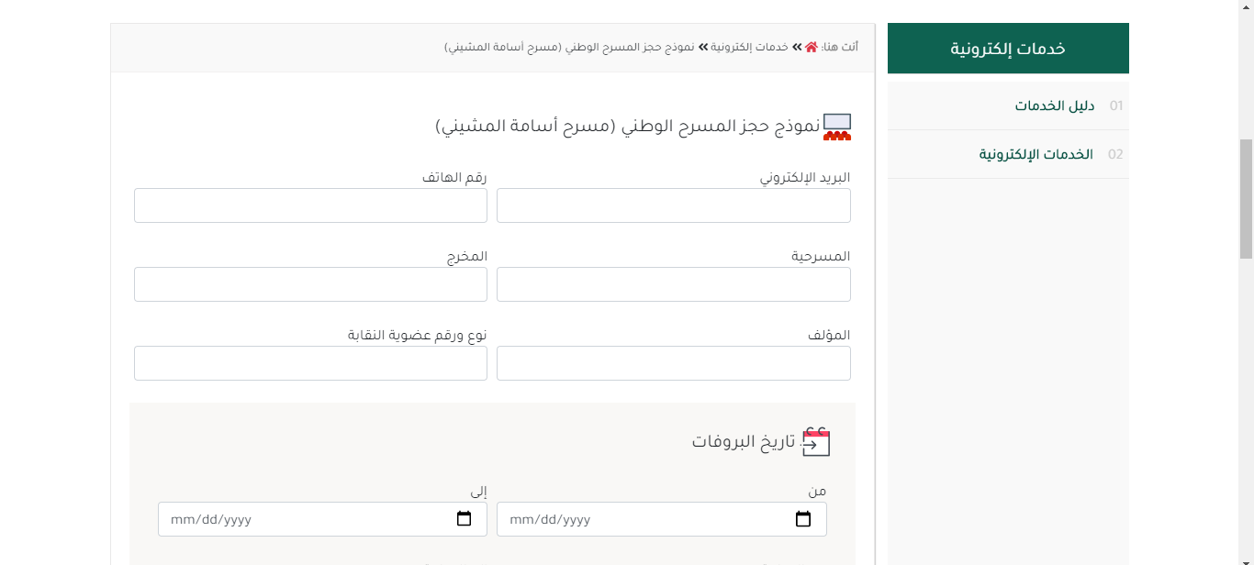

Figure : Service 1 - Book National stage

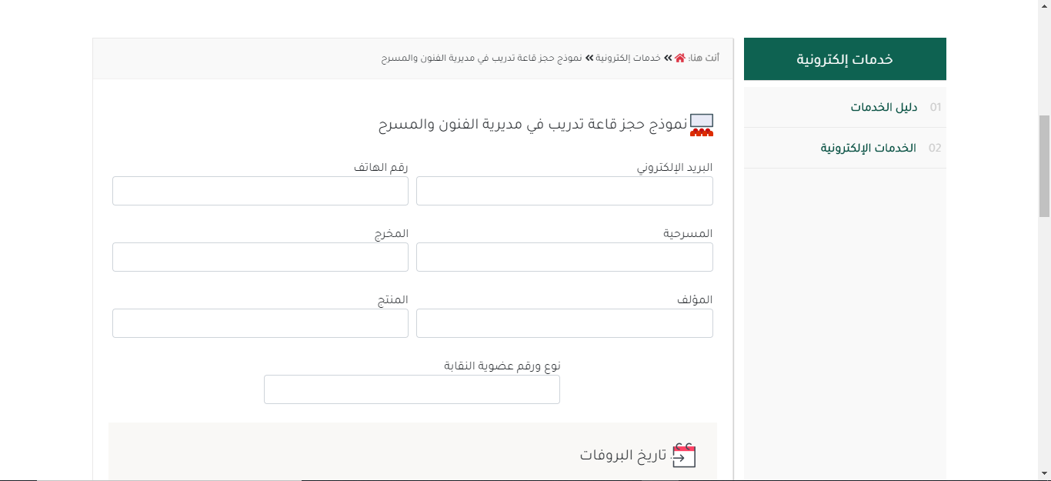

Figure : Service 2 - Book national stage training room

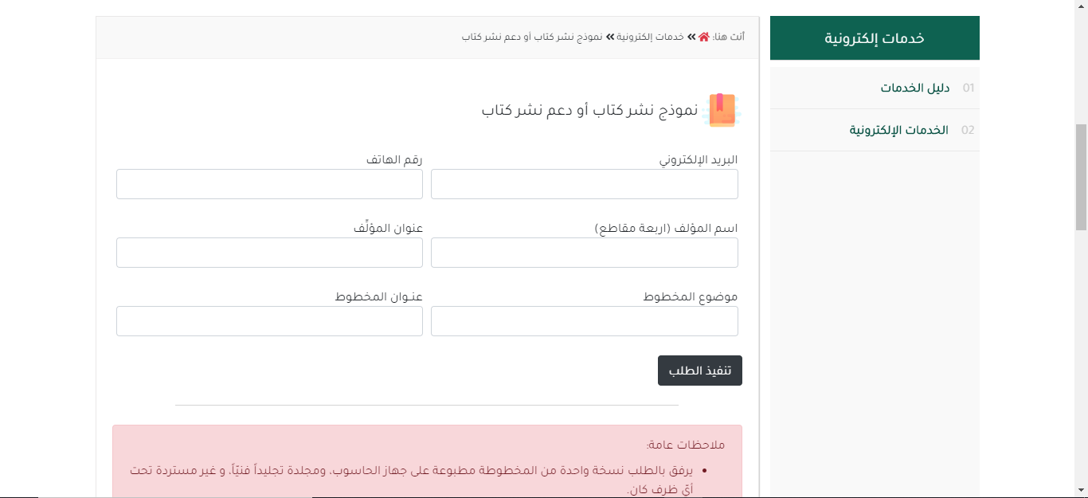

Figure : Service 3 - Publish Book

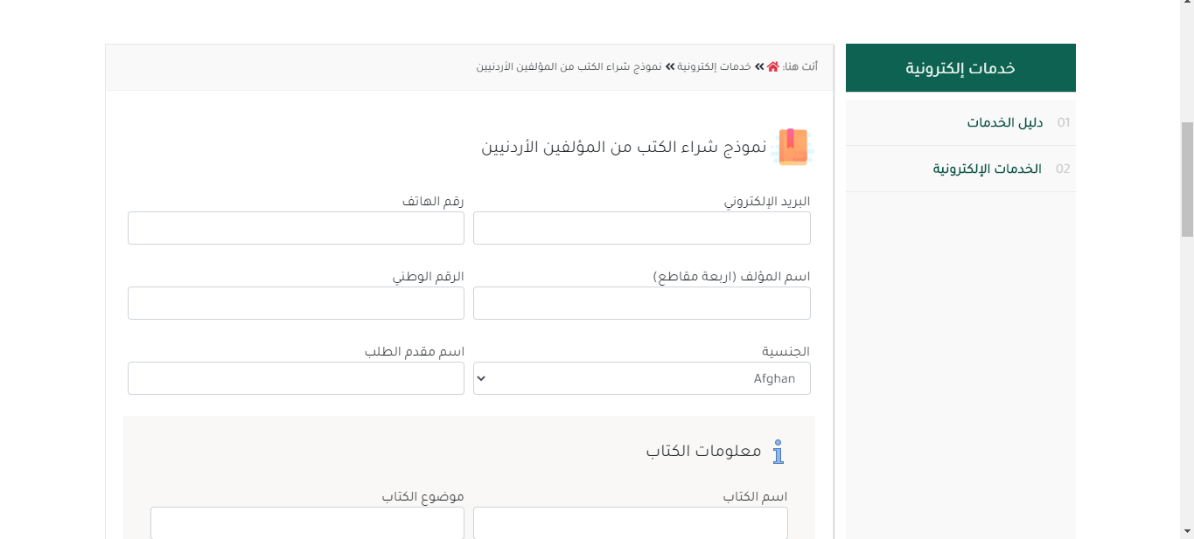

Figure : Service 4 - Buy book from Jordanian writers

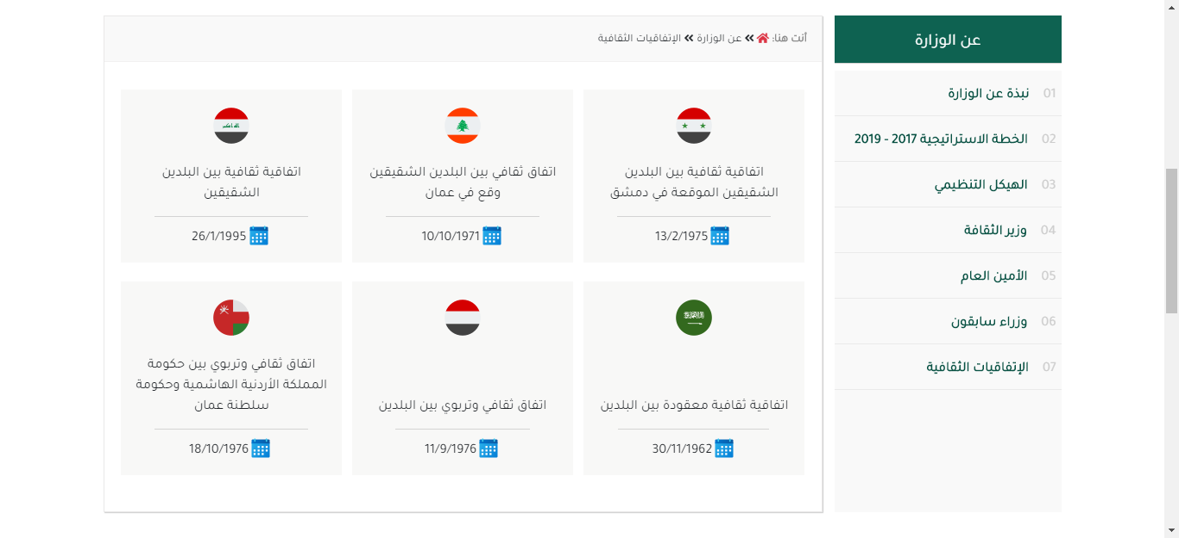

Figure : Cultural Agreements

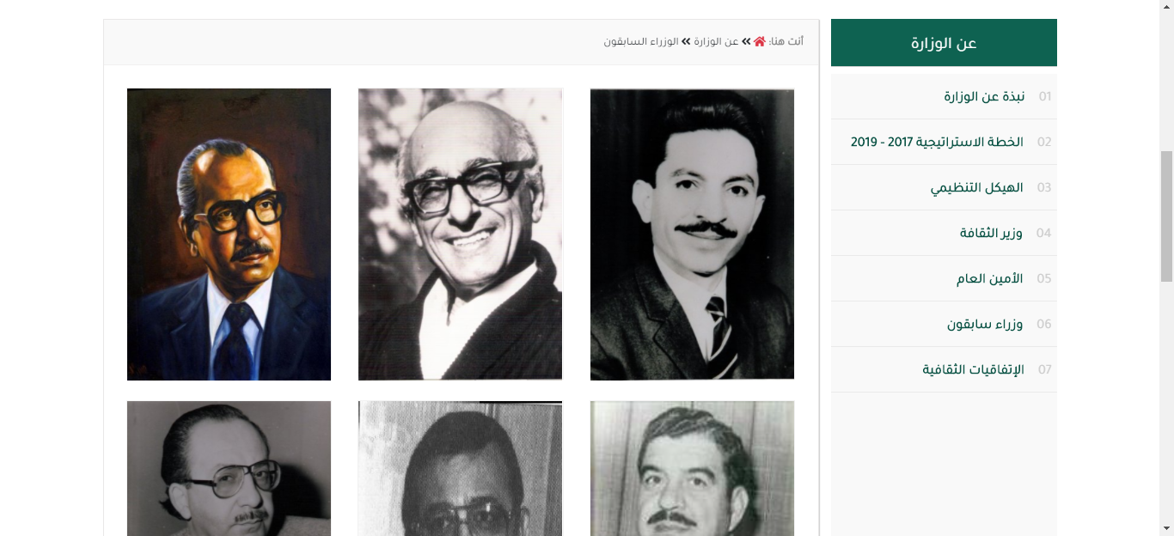

Figure : Prev. Ministers



Figure : Contact us - 1

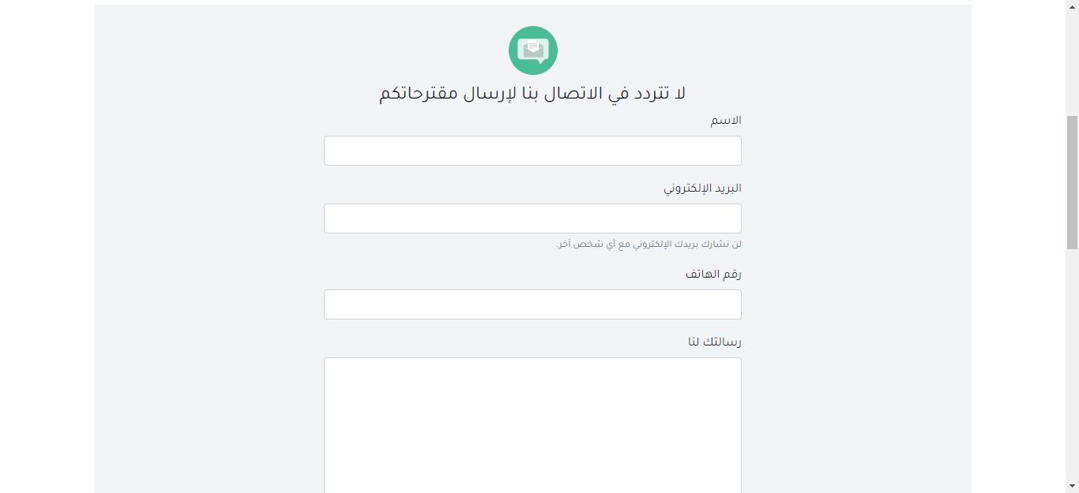

Figure : Contact us - 2

# Source code Excerpts:

In this section, I will show some parts of the source code into two parts. First part is related to the frontend design, and it will show the code of some components from the website. Second part is related to the backend structure, it will show the php code of some sections which renders the data into the screen, and other parts of the code that show how the services were built.

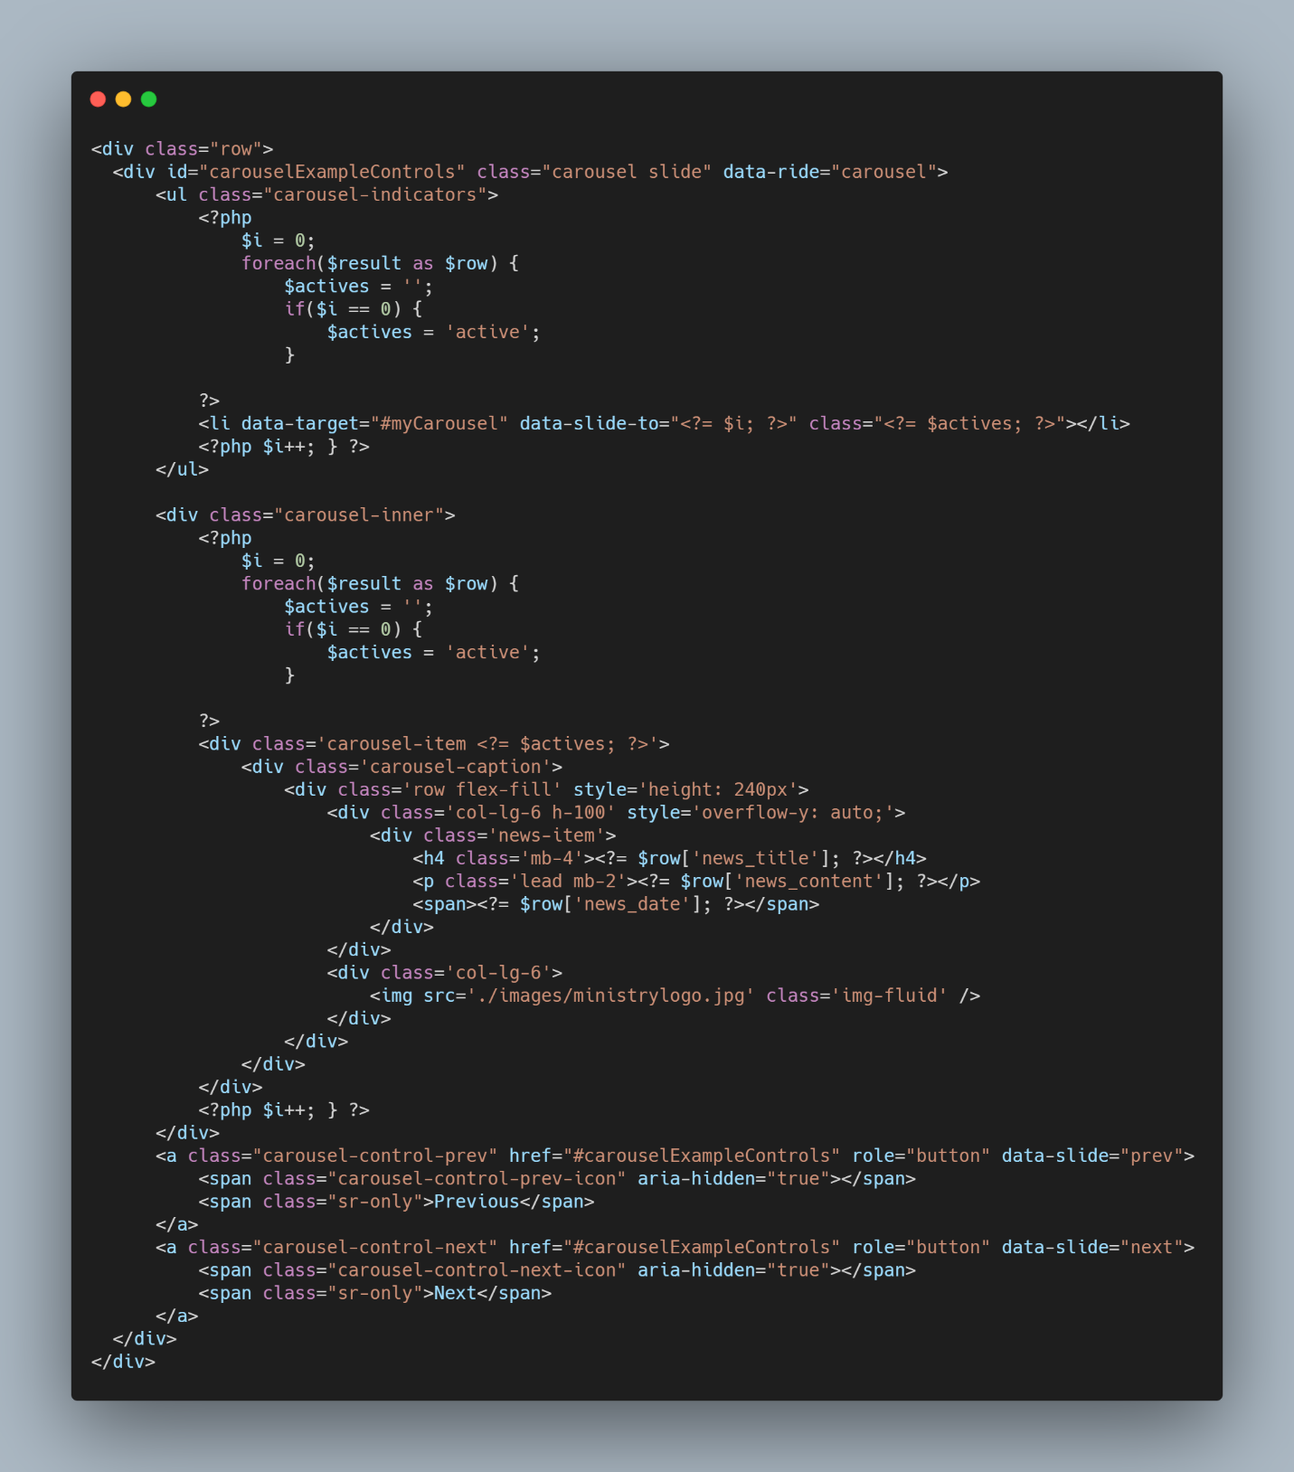

Figure : Home Page - News Section

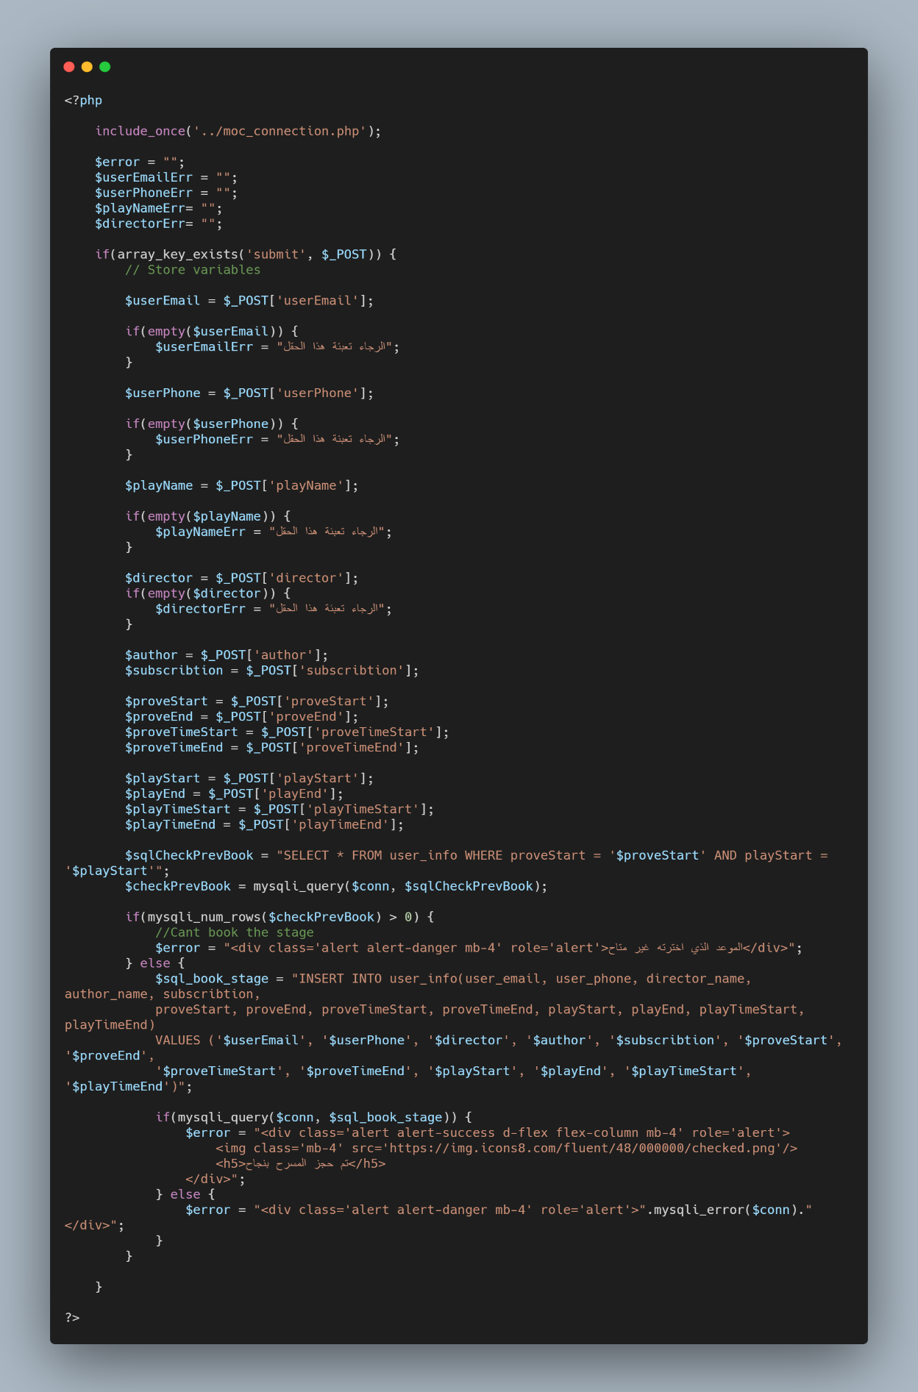

Figure : Service one - PHP Code

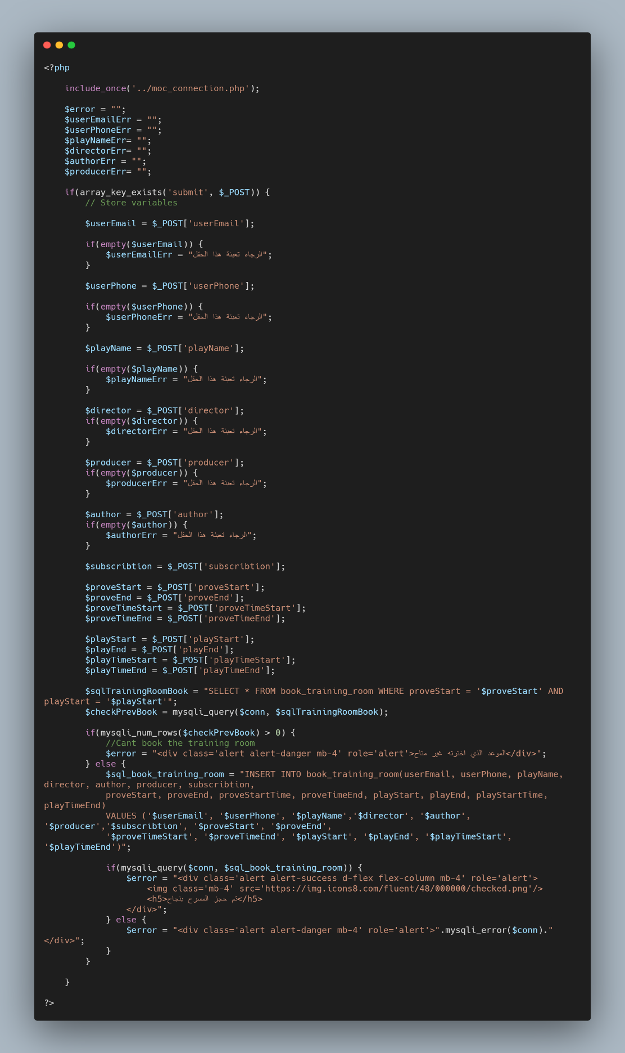

Figure : Service 2 - PHP Code

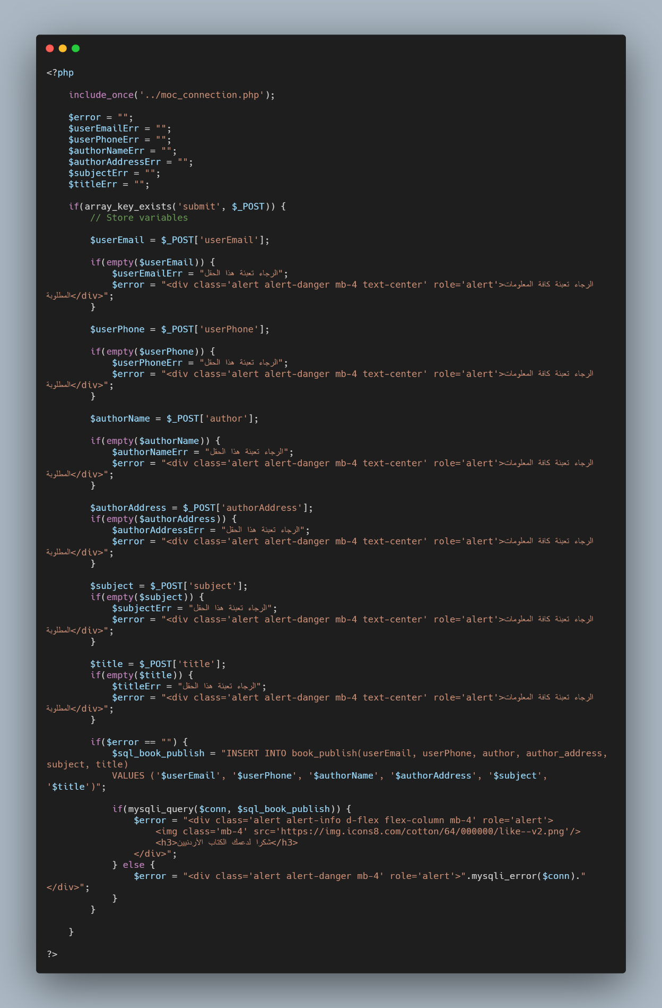

Figure : Service 3 - PHP Code

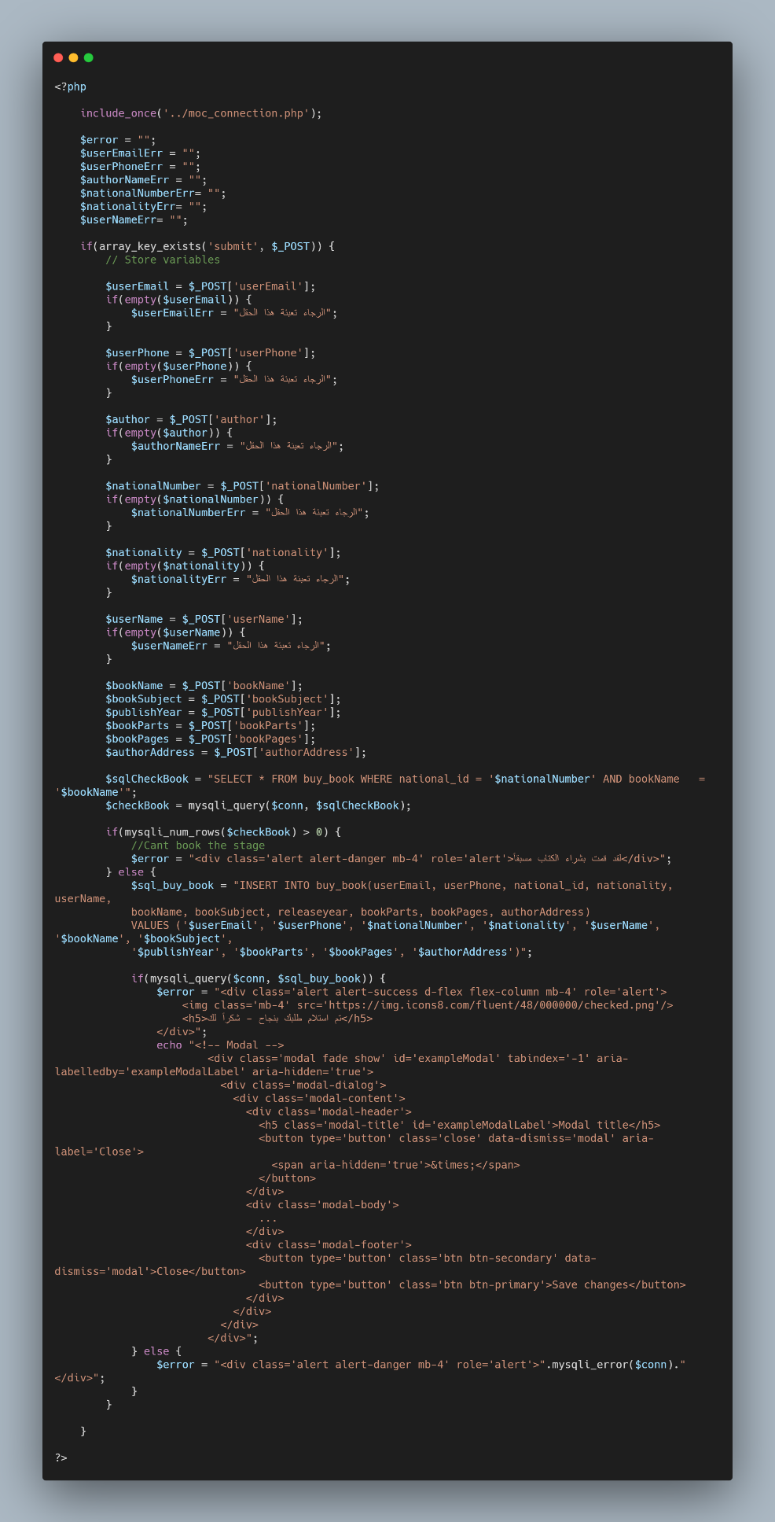

Figure : Service 4 - PHP Code

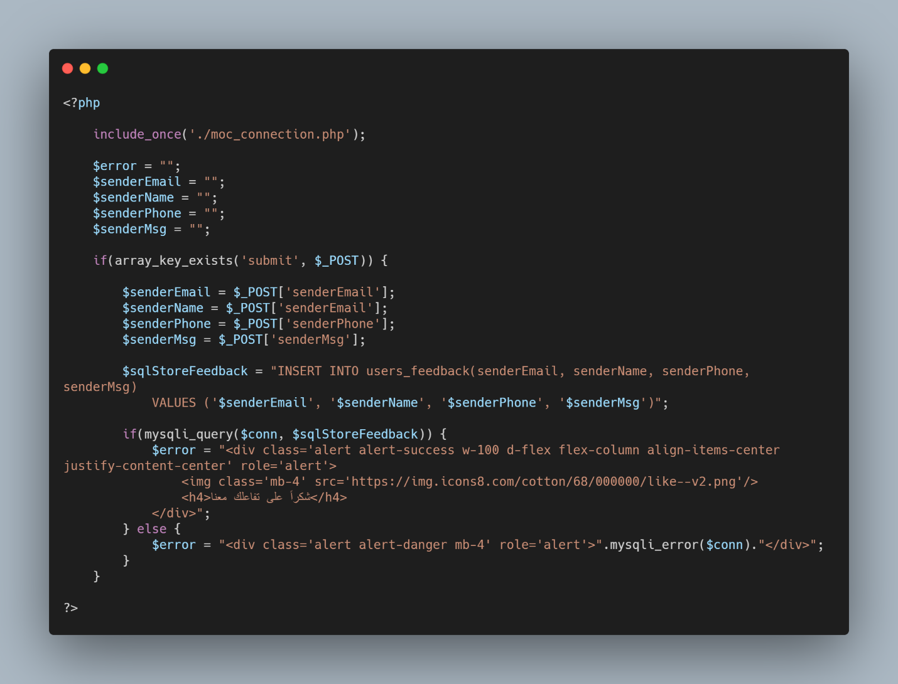

Figure : Contact Us - PHP Code

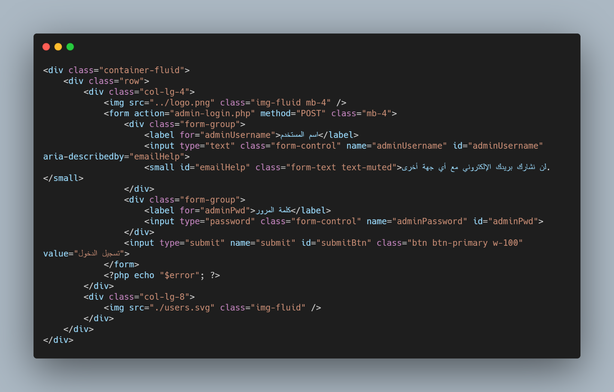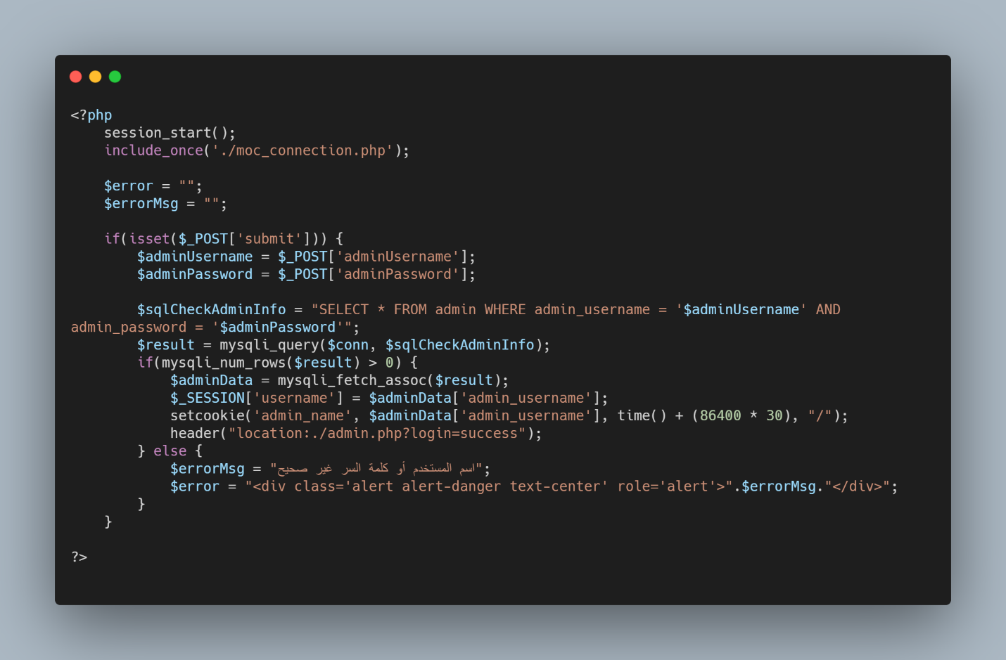

Figure : Admin Login - HTML Code

Figure : Admin Login - PHP Code

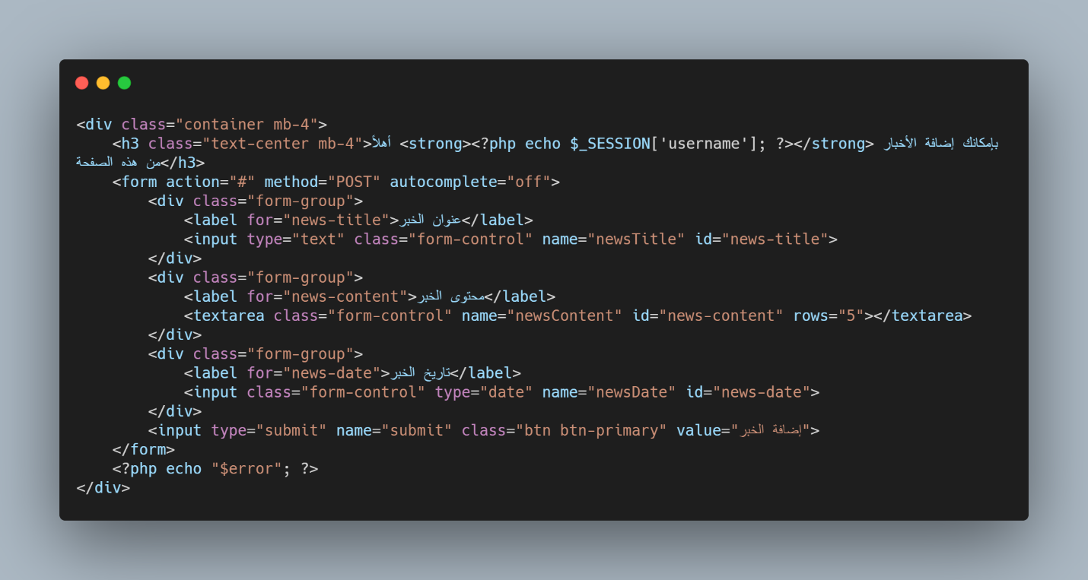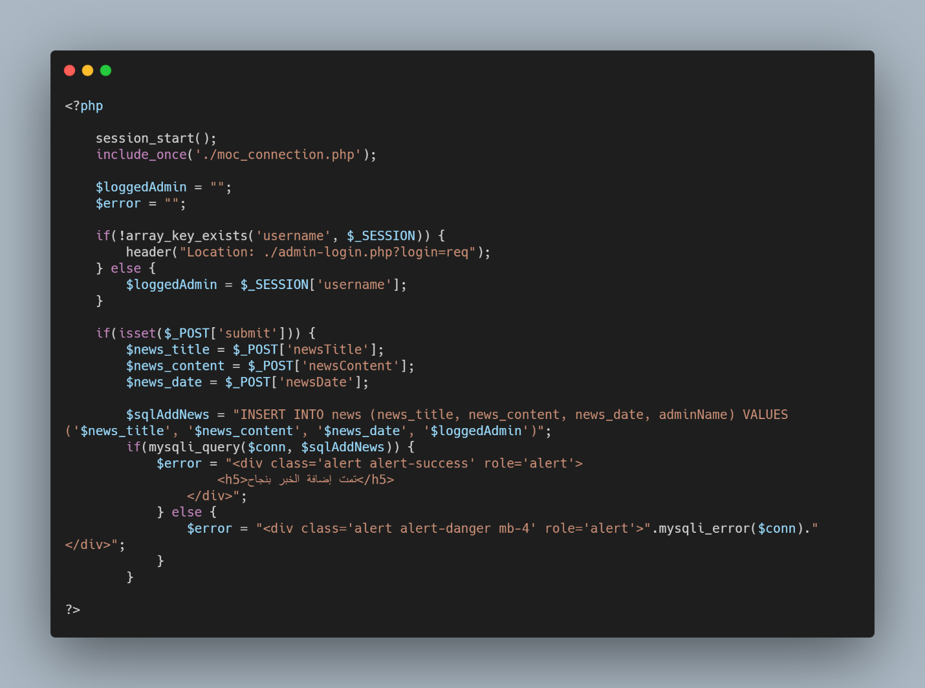

Figure : Add News - HTML Code

Figure : Add News - PHP Code

# Conclusion:

The new website makes it easy for all users to access it form any device. It was designed using best technologies to make it easier on both users (normal, admin) to deal with the website. Also, the problem of “bad looking” design had been solved in the new one. In this way, we can share our country’s culture for the whole world in the best way.